**Trillium Miata Club – 2024 Lake Placid Tour**



***Friday May 17 to Monday May 20, 2024***

**WHERE ARE WE STAYING?**

Once again, we will be staying at **The Lake House:** 1 Mirror Lake Drive, in downtown **Lake Placid, New York** (part of the High Peaks Resort complex) [www.highpeaksresort.com](http://www.highpeaksresort.com)

**The Lake House** has only 44 rooms available and the entire Hotel is available for our event if we can fill it. It is located right in the heart of downtown Lake Placid. Mirror Lake is steps away, with complimentary boats to use, on-site restaurants, recently renovated guest rooms and 4-star guest service with spectacular views. Walk out the front door to all of the shops, restaurants, galleries and Olympic offerings of Lake Placid (Host City of the 1932 and 1980 Winter Olympics).

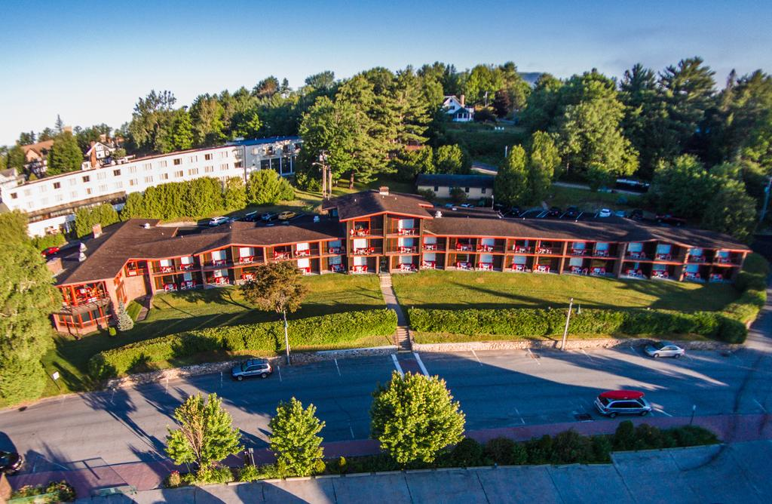 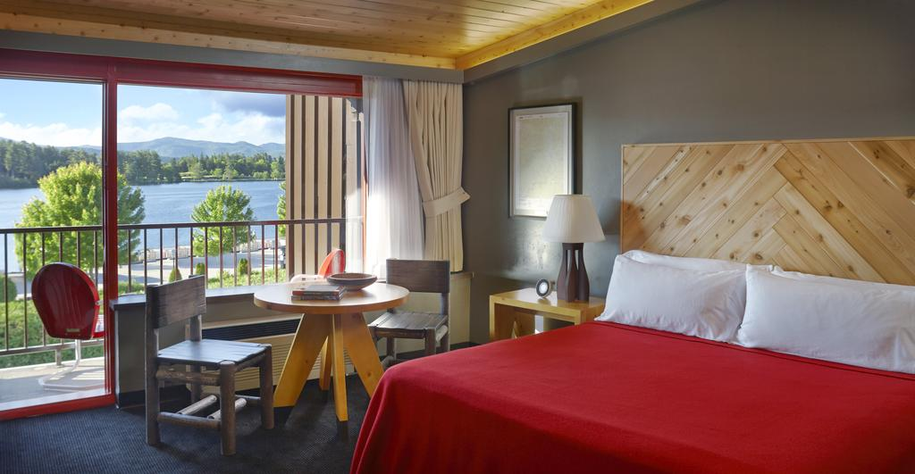

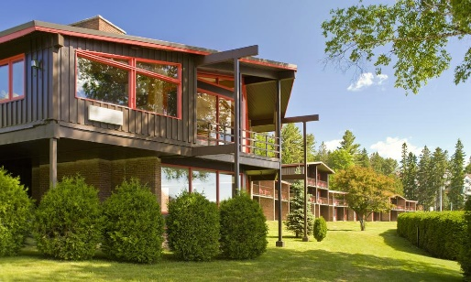 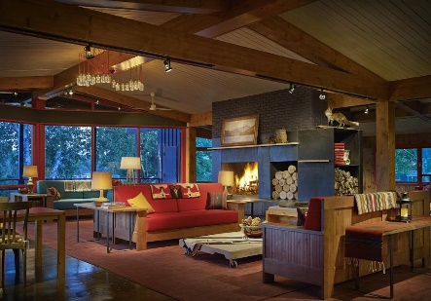 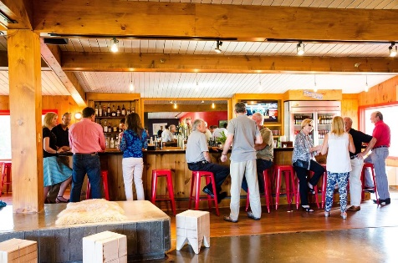

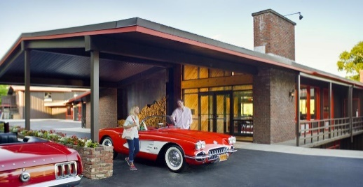 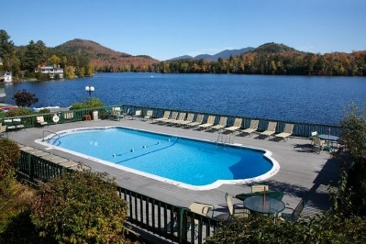 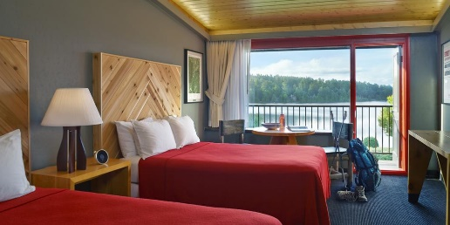

*Photos courtesy of High Peaks Resort/Lake House*

Lake House guests have several pools for their guests to use and Whiteface Mountain and Mt. van Hoevenberg are an easy 15-minute drive away. **Lake House guests have the full run of the amenities of the High Peaks Resorts complex. For us, once again, the lake House will be offering:**

* Complimentary champagne upon arrival
* Complimentary off-street parking
* Complimentary wireless internet
* Complimentary car wash stations

**THE ROOMS**

**The Lake House has 1 price category of rooms with the differences between them being beds and balcony/walkout formats**. Of the 44 rooms, 8 rooms have “King Size” beds, 32 rooms have 2 “Queen Size” beds, and 4 rooms have 1 “Queen Size” bed. As we have in previous years, you will be asked to specify your #1, #2 & #3 choices of rooms when you register with Tour Leader Gary Svoboda.

|  |  |  |  |  |  |  |  |  |  |
| --- | --- | --- | --- | --- | --- | --- | --- | --- | --- |
| **Room Category** | **# of Rooms Available** | **Room Rate Per Night**  (all costs in $US, plus applicable taxes (11%) & Resort Fee (7%) | | | | | | | **Closing Sunday Dinner**  **($US - taxes & gratuities extra)** |
| Wed May 15 | Thu May  16 | **Fri May**  **17** | **Sat May**  **18** | **Sun May**  **19** | Mon May  20 | Tue May 21 |
| Upper Level – King | 3 | 129 | 129 | **159** | **159** | **159** | 129 | 129 | $48.00 per person |
| Upper Level – 2 Queen | 15 | 129 | 129 | **159** | **159** | **159** | 129 | 129 |
| Upper Level – 1 Queen | 2 | 129 | 129 | **159** | **159** | **159** | 129 | 129 |
|  |  | 1 |  |  |  |  |  |  |
| Lower Level – King | 3 | 129 | 129 | **159** | **159** | **159** | 129 | 129 |
| Lower Level – 2 Queen | 15 | 129 | 129 | **159** | **159** | **159** | 129 | 129 |
| Lower Level – 1 Queen | 2 | 129 | 129 | **159** | **159** | **159** | 129 | 129 |
|  |  |  |  |  |  |  |  |  |
| Third Level – King | 2 | 129 | 129 | **159** | **159** | **159** | 129 | 129 |
| Third Level – 2 Queen | 2 | 129 | 129 | **159** | **159** | **159** | 129 | 129 |

* **Most Upper Level Rooms have balconies, most Lower Level Rooms have walkouts.**
* **Nights in yellow are compulsory. $159 is the average nightly rate for the 3 nights. Actual nightly rates will vary on your bill.**
* **Above room rates not inclusive of taxes – taxes are 8% NY State Tax plus 5% Occupancy Tax plus 7% Resort Fee Tax**
* **Breakfast is additional and on your own, available from 7 am at the Dancing Bears Restaurant located in the Main High Peaks Resort Tower, or elsewhere if you wish. Plan to be in the Hotel Parking Lot by 8:30 AM for the daily tour briefing.**

**OTHER CLUBS INVITED**

For 2024, members of the **Vermont Miata Club** will again be invited. **All non-TMC participants will have to complete the same application form PLUS complete the TMC’s Hold Harmless Form.**

**PARTICIPATION REQUIREMENTS**

* **All Participants on this Tour MUST stay in the Lake House Friday night, Saturday night and Sunday night.**
* **We strongly encourage all participants be fully vaccinated for COVID-19.**
* **Must be active member of Trillium (or Vermont) MCs at the time of the Tour.**
* **Vermont members must return TMC Hold Harmless form with registration.**
* **Your Miata must be in good mechanical condition.**
* **You must have a working CB radio in the car.**
* **There is a mandatory $Cdn 40 per person ($30 US) registration/gear fee**

**EXTENDED STAY OPTION:** For any members who would like to enjoy Lake Placid a little longer, the Lake House is offering an even lower reduced rate for the 2 days before and the 2 days after our tour, based on availability at time of booking ($129/night).

**DEPARTURE POINT:** As in pervious years, we will be offering the option to members of driving in a group, departing from Kingston Thursday and Friday morning (Location TBA). Or, you can organize your own groups or come down individually.

**DAILY TOURS:** On the Saturday and Sunday there will be tours of the New York & Vermont countryside and lunch locations will be arranged. Each day’s tour will end at the lunch location leaving the afternoon free for sightseeing, shopping or relaxing. Once again, there will also be a Friday Early Bird Tour.

**Sunday - CLOSING DINNER:** Our traditional closing dinner will take place in on Sunday, May 21st . Dinner will be a buffet and will include appetizers, soup or salad, entrées and desserts – **attendance by all is expected**. This dinner will cost $48 per person (plus taxes and gratuities). The hotel will in all cases automatically charge the dinner to each participant’s hotel bill.

**NEXT STEPS:** Please complete the information and submit electronically through the website. Or, complete & submit the **Registration Form** along with your **$80 CDN/$60 US) per couple** ($40 CDN/$30 US per person) **registration fee to Gary Svoboda at garysvoboda@rogers.com**. For questions, call Gary at 519-824-7456.