

**Ottawa Region on Canada Day**

**And Gatineau Tour**

**June 29th to July 2st**







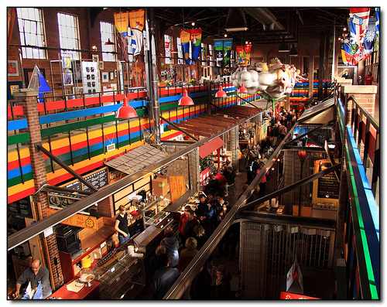

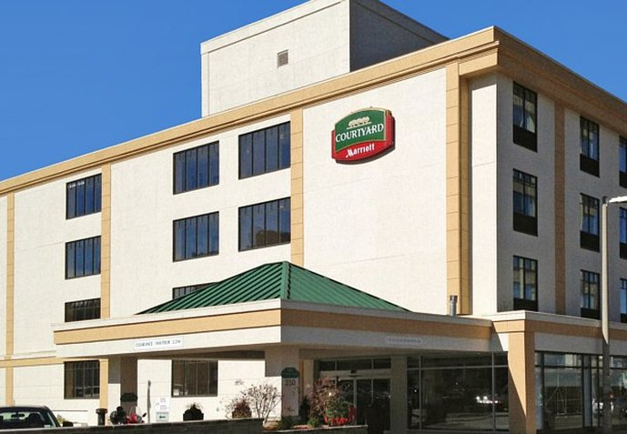







* **Sun. June 29th.** Pickering to Ottawa tour. Arrive and relax at the Marriott Courtyard Ottawa.
* **Mon. June 30th.** Gatineau Tour. 4 to 5 hours. No speed records will be broken here.
* **Tues. July 1st.** Canada Day Festivities. Our Miata’s get to rest. You will have many sites to visit during the day and later enjoy our nation’s best fireworks display.
* **Wed. July 2nd.** Go home**.**

**Please contact me asap if you are interested.**

**This is selling out fast.**

**Bernie Poirier**

[**Jbpoirier@sympatico.ca**](mailto:Jbpoirier@sympatico.ca) **905-877-5345**