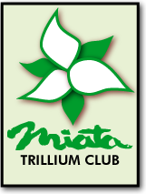  Trillium Miata Club  Presidents Kingston Tour  Friday August 1st – Monday August 4th Registration Form  Contact: Patrick Sullivan plsullivan1@sympatico.ca  519-650-7401  TMC Membership / CB Radio / Passport Required  Registration Opens April 25, 2014 | 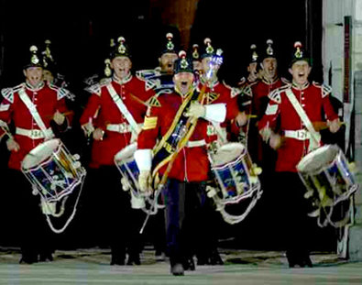
Driver Name:

Co-Pilot Name or None:

Phone #: Home
Cell

Email Address:
Year
Miata: Plate #;

Make your way on your own Friday to the Hotel and meet up at 6:00 PM for Orientation in the Hotel Pub (aka: Tom’s Place) And don’t forget your passport!!!!!
Details to follow

Will You Lead and/or Sweep Lead Sweep

You must Have a working CB Radio to participate

Emergency Contacts 1)

. 2)

HOTEL,
August 1st to August 4th stay.
Best Western Fireside Inn, 1217 Princess Street, Kingston, Ontario, K7M 3E1, Phone: 613-549-2211
www.bestwestern.kingston.on.ca

The negotiated cost is $140.00/night + tax. (Make sure to reference Trillium Miata Club when booking)

Important,
Hotel bookings must be done by June 30th in order to secure the rooms at this reduced rate.

I did reserve my room yes_______ no_______

Note: Registration is limited to 15 cars for this tour due to Room Availability

