Join us August 1st through August 4th for tour of the roads and attractions around Kingston and 1000 Islands. Starting on Friday the 1st in the Pub at the Best Western Hotel in Kingston for an informal Meet and Greet.

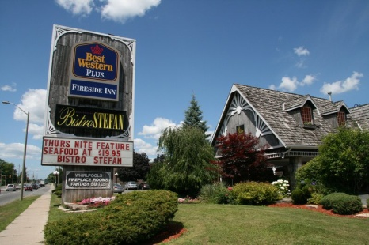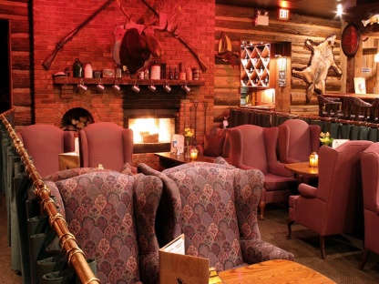

On the Saturday morning we will transit via 2 ferries over to the US side and take a casual drive along the US coastline heading east then back over the bridge to Canada

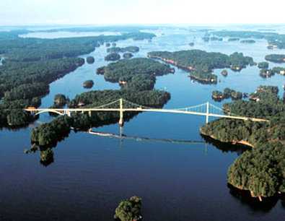

and on to Rockport for Lunch at the docks. Those interested can take the 1000 island tour at Rockport or the partial island tour which would include Heart Island and the Bolt Castle.

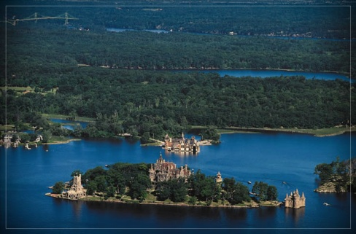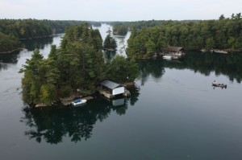

Or you can continue on with the driving route through the roads north of the 401 back to Kingston and the Hotel. Saturday night we can partake of the attractions along the Kingston waterfront and enjoy the festivities the city has to offer for the long weekend.

On Sunday we will have a leisurely morning and for those not heading back that day, we would plan an outing to Fort Henry as well as some of the museums in the local area.

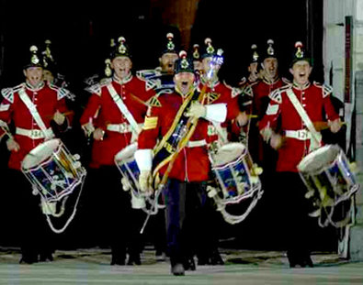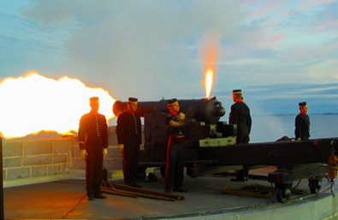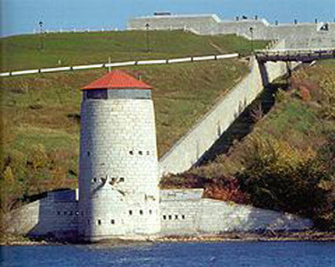

We would finish off our day with a group meal in the Hotel Restaurant.

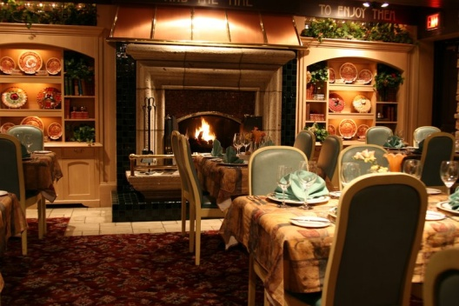

So keep an eye out for additional details & tour registration in the coming months as this is one you may not want to miss.