**Topless In the Mountains**

**West Virginia – August 29 to September 1, 2014**

Once again planning is in process for the 2014 West Virginia Tour that will take us to the scenic back roads around Elkins WV. This year marks the 20th anniversary of this tour. Last year’s tour was a huge success and was greatly enjoyed by all those that participated. We are planning on making 2014 even better.

For those that have not experienced this tour previously I can say with confidence that the West Virginia area has some of the greatest Miata roads in North America along with some of the nicest scenery anywhere. The 2014 tour is designed to get us into the heat of those roads and that scenery.

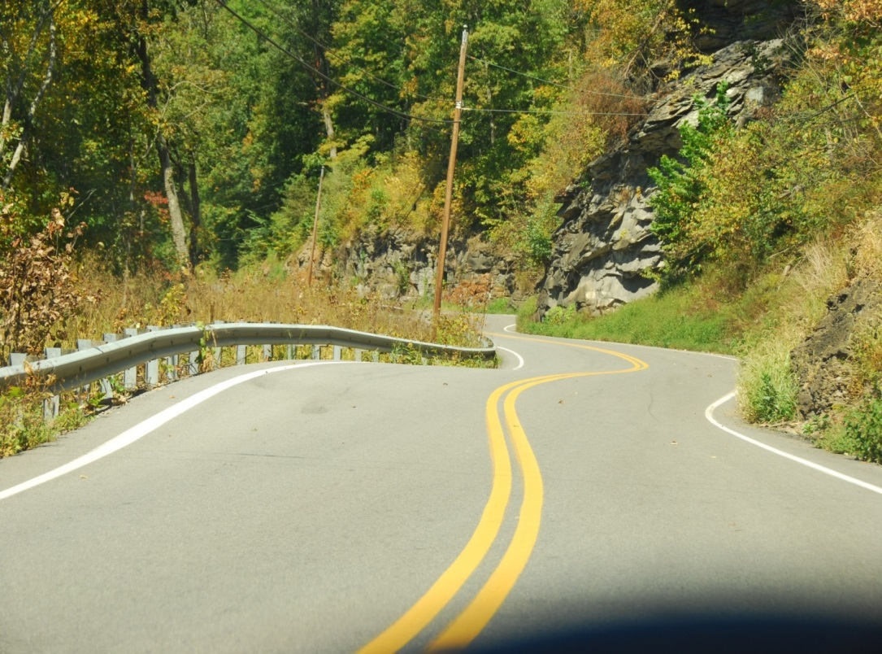

**Highlights of the 2014 West Virginia Tour**

* All 3 nights in West Virginia will be at the Hampton Inn in Elkins WV
* We will have 2 days of driving the fantastic West Virginia scenic twisty roads which surround the Elkins WV area
* We are planning shorter tour days with an anticipated mid-afternoon arrival back at the hotel and with sightseeing stops along the way
* Here is a Thursday overnight option at the Hampton Inn, Buffalo South to avoid Friday morning border delays
* Again for 2014 several members of the West Penn Miata Club may join us

**Tour departure**

The tour will depart from the Hampton Inn Buffalo South parking lot promptly at 8:00 AM Friday morning.

**Thursday August 28**

Overnight stay at the Hampton is not required but recommended due to the Friday departure time and the potential for delays at the Fort Erie border crossing.

You are free to arrive, at the Hampton Inn Buffalo South (just off I-90 at 1750 Ridge Road, West Seneca, New York, USA 14224). at your leisure, anytime Thursday afternoon or evening. As indicated above the tour will depart from the Hampton Inn Buffalo South parking lot promptly at 8:00 AM Friday morning.

A special; rate of $159.95 (taxes extra, breakfast included) has been arranged. Reservations can be made at 716-824-2030. Don’t forget to mention the Trillium Miata Club to get the group rate.

.

**Friday, August 29**

We are planning a leisurely drive south on scenic Hwy 219 staying off the interstates and enjoying the scenery along the way. With relaxing breaks and lunch along the way we expect to get to the hotel before 5:00 PM.

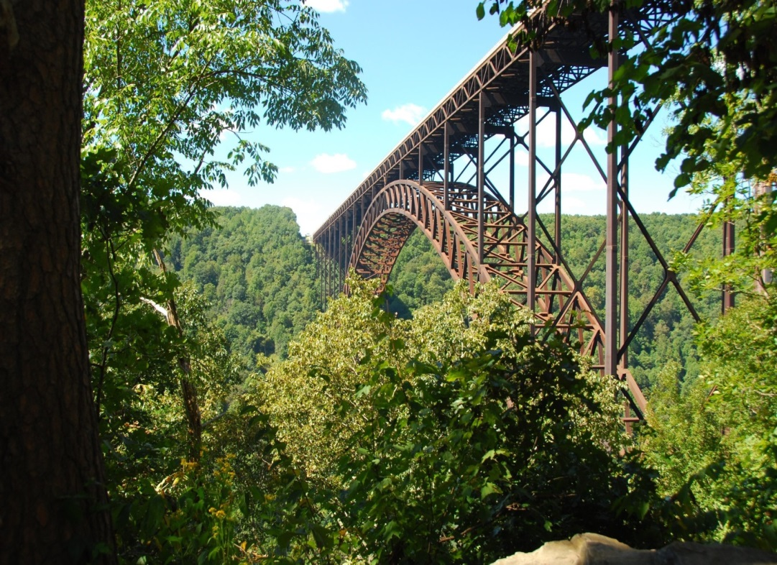

**West Virginia Hotel Accommodations**

You must make your own hotel reservation at the Hampton Inn in Elkins. A special group fate has been negotiated for the weekend as follows:

**Friday, Saturday, Sunday, August 29 to August 31, 2014 (departure September 1)**

[**Hampton Inn Elkins**](http://res2.hilton.com/webservices/echoengine/T.aspx?l=H_476183087_2001737_112408_1546760290&u=aHR0cCUzYSUyZiUyZnd3dy5oYW1wdG9uaW5uLmNvbSUyZmVuJTJmaHAlMmZob3RlbHMlMmZpbmRleC5qaHRtbCUzZldULm1jX2lkJTNkRVBFTUhYUmVzY29uZkVOJTI2Y3R5aG9jbiUzZEVLTldWSFg=&t=228), 480 Plantation Drive, Elkins, WV, 26241

Tel: 1-304-630-7500 Fax: 1-304-630-7501

Room Rate: $109.00 per night (plus taxes breakfast included)

**Saturday, August 30 & Sunday August 31**

On Saturday and Sunday we will explore some of the great mountain back roads of northern and central WV. While routes have not been finalized yet the intent is to keep the day’s tour shorter so that there is time for sightseeing both along the way and after the day’s run.

**Monday September 1**

Return home at your leisure

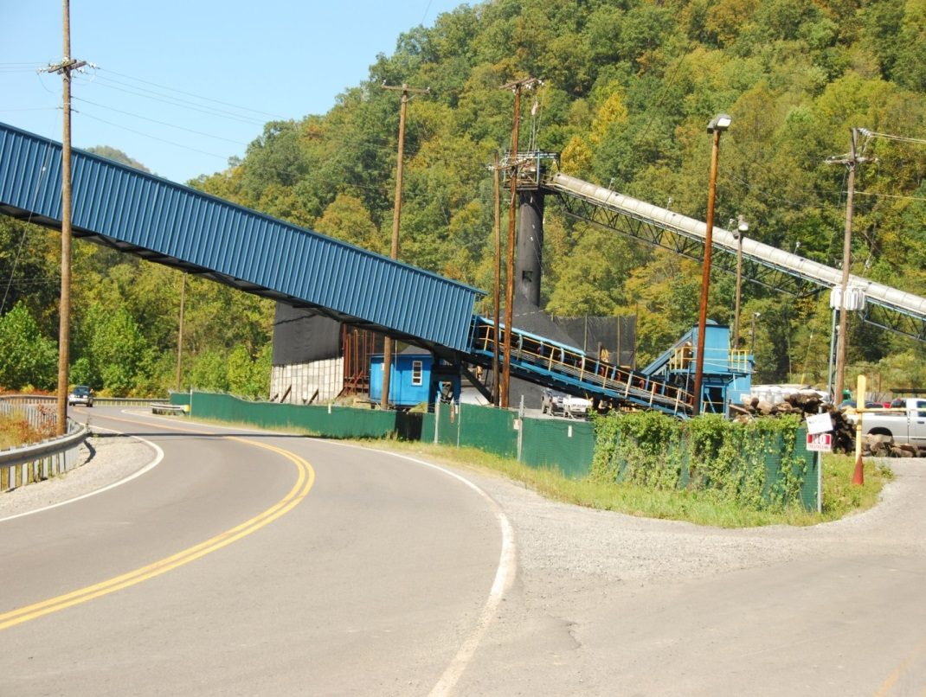

**Leads and Sweeps**

Ideally in West Virginia we try and keep the group sizes to about 5 cars. I am asking on the registration form if you are willing to lead or sweep. As always leads and sweeps are an important and necessary part of the success of the tour. Please consider volunteering.

It is always a lot of fun down in West Virginia, and I would encourage the club members to join us on this year’s tour and have a great weekend enjoying your car.

**Registration and Reservations**

**For 2014 the cut-off for registration will be June 30**

No registration will be accepted past that date

Don’t delay. Complete the required registration form and email back to Richard Rutsch at

[**topless.in.wv@gmail.com**](mailto:topless.in.wv@gmail.com)

And then make your hotel reservations:

**Hampton Inn Buffalo South, 1750 Ridge Rd West Seneca, NY 14224, United States**

716-824-2030, RATE $159.95, one night, Thursday, August 29

**Hampton Inn Elkins, WV. 480 Plantation Drive, Elkins, West Virginia, 26241, USA** 304-630-7500 RATE $109.00, Three nights, Friday, August 28th, to Sunday August 31 (check out Monday, September 1)

Name of Group “**Trillium Miata Group**”, to be given at time of reservations at the hotels.

**After completing hotel reservations please confirm hotel reservations have been made by email to** [**topless.in.wv@gmail.com**](mailto:topless.in.wv@gmail.com)