MAY 23rd

CAMBRIDGE NORTH TOUR

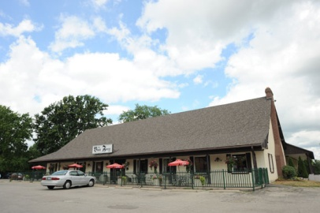

**Black Forest Inn – Conestoga -- Home of the Showplace Dinner Theatre**

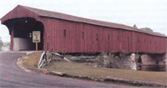 **West Montrose Covered Bridge (Kissing Bridge)**

**Tour starts from the Timmies at the corner of Townline Road and Jamieson Parkway (just north of the 401, interchange 286) drivers meeting 9:30 am.**

**CAMBRIDGE MAY NOT BE AN EXOTIC PLACE, BUT THE AREA HAS MANY SCENEIC THINGS TO SEE!**

THE TOUR WILL TAKE US EAST, WEST, & NORTH OF CAMBRIDGE!

I DARE SAY THAT THIS TOUR IS COMPLETELY NEW AND REFRESHING WITH UP/DOWNS, TWISTIES, ROUND-A-BOUTS, A STOP AT THE COVERED BRIDGE IN WESTOVER, will be on the agenda

SIGHTS WILL INCLUDE, THE COVERED BRIDGE IN WESTOVER, THE GEORGE AREA OF ELORA, WE’LL PROBABLY ENCOUNTER NUMEROROUS HORSE AND BUGGIES WITH MEMONITE FAMILIES.

THE AFTERNOON WILL SEE US AT THE AREAS FAMOUS GERMAN EATERY, “THE BLACKFOREST INN” WHERE THEY WILL HAVE MANY TRADITIONAL GERMAN FARE, AS WELL AS A SOUP AND SALAD BAR.

PARKING IS AMPLE AT THE RESTAURANT AND WE SHOULD MAKE AN IMPRESSIVE DISPLAY, OF OUR LITTLE BEAUTIES.