INCLUDEPICTURE "http://www.trilliummiata.com/templates/miata/images/logo-green.png" \* MERGEFORMATINET INCLUDEPICTURE "http://www.trilliummiata.com/templates/miata/images/logo-green.png" \* MERGEFORMATINET INCLUDEPICTURE "http://www.trilliummiata.com/templates/miata/images/logo-green.png" \* MERGEFORMATINET INCLUDEPICTURE "http://www.trilliummiata.com/templates/miata/images/logo-green.png" \* MERGEFORMATINET  | Trillium Miata Club  2015 Driver's Tour – June 20 & 21, 2015  Registration Form  Contact:  Michael Darragh ifurita143@yahoo.ca  Requirements: Active TMC member with current TMC Annual Membership Form on file / Miata in good mech. condition / CB Radio

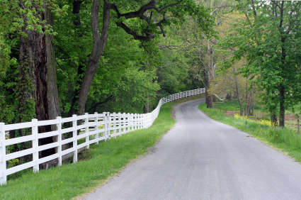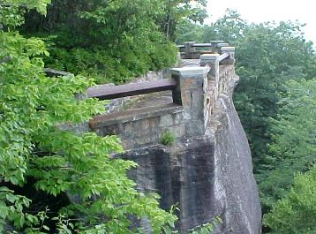

Registration Information:
Names: | Driver: | Co-Pilot
Phone Numbers: | Home: | Cell:
Email Address:

Will you sweep?: | Sweep (Y/N)
Emergency Contacts:

All registration forms to be returned to ifurita143@yahoo.ca
(See notes on next page)

Tour Notes - Driver's Tour (Sat Jun 20 - Sun Jun 21)

Some tours feature wineries. Some tours feature scenery and fall colours. The Driver's Tour features one thing only - the twistiest back roads within a day's drive of Toronto.

This two day excursion traces a winding loop through the states of New York and Pennsylvania in search of challenging roads - the kind with hairpins, hills and dips, and barely enough tarmac for two cars to pass each other.

The Saturday itinerary features over 6 hours of back roads driving, including a night-time sprint to the hotel. Exhaustion will battle with exhilaration as you collapse into your hotel bed, for you will truly understand the meaning behind the Miata design philosophy "Jinba Ittai" at the end of this day.

Sunday features a more direct route to ensure an early evening return to Toronto, but still includes a number of back road diversions to break up the highway miles and keep us alert.

Due to the challenging nature of the roads featured in this tour, the number of participants will be limited to 5 cars. Tires with AA temperature rating are recommended and your suspension components should be in excellent working order.

Please contact Michael Darragh at ifurita143@yahoo.ca if you are interested in participating in this tour. Once your registration has been received, details for contacting the hotel will be provided. There is no registration fee for this tour.
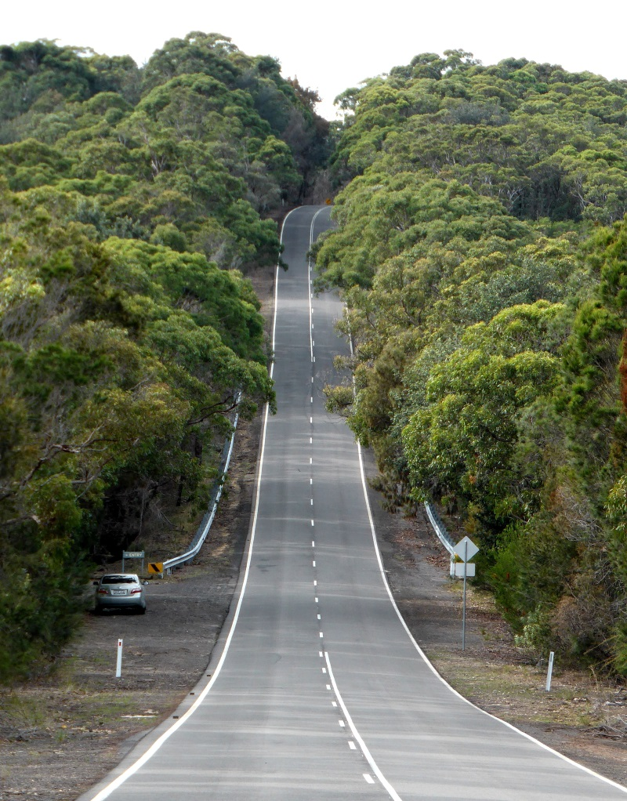
Itinerary:

SAT
08h00: Meet at QEW and 3rd Line
11h30: Lunch at Thunder Valley Buffet in the Seneca Casino
13h00: Hike or Swim at Rim Rock Lookout in Allegheny State Park
16h30: Ice cream stop in Ridgway, PA
17h30: Dinner at The Dam Inn in Wilcox, PA
22h30: Arrival at hotel in Williamsport, PA

SUN
08h30: Depart hotel after complimentary breakfast
12h30: Lunch at Cast & Crew restaurant
18h30: Arrival in Toronto area

