TRILLUM MIATA Mystery TOUR 2015

Tuesday June 23rd and 24th

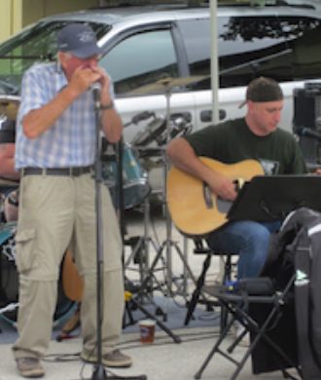

**It may not be the Beatles but he can sure play the harmonica better than McCartney**

**Pat Onions is pleased to present the Trillium Miata club’s first ever mystery tour.**

All we know is that GPX files will not be handed out nor do we expect a map. Pat is simply not willing to divulge the where abouts of this tour other than the departure point and possibly the hotels.

Ooh!...Sounds Mysterious

On Tuesday, June 23rd We will all meet in Stayner at 9:00AM sharp. There is a small business plaza on the right after you pass through the lights at Hwy 91 & 42. There is a Tim Hortons on the south-east side but it is conjested and not a lot of room for the cars. We will be heading up hard surface roads heading west. There will be a lunch stop. The details of the route and location of the overnight stop will for now remain a mystery. Pat has arranged for 14 rooms at this Mystery location. The price will range between $95 and $110 per person including dinner and breakfast on the morning of the 24th.

On Day 2, (June 24th), Pat will have some great drives and scenery, a place for lunch stop followed by an additional route east finishing in the Collingwood area. If anyone would be interested in accommodations for a second night in this area, please let us know.

Please respond to Dona & Dennis Allard at 905-450-7622 or [den.dona@trilliummiata.ca](mailto:den.dona@trilliummiata.ca). A registration form will follow.