April meeting at the Royal Canadian Legion- Toronto

Enclosed is a google map of the Legion for Aprils Meeting. The Red arrow is pointing to a block of red. This indicates the Legion building. The parking is ample on Net Drive or behind the legion building.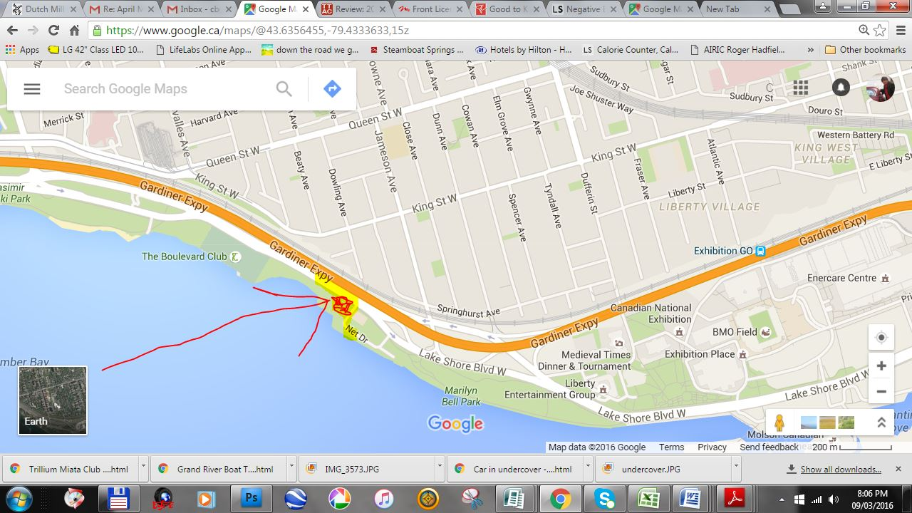

Turn on to Net drive. Turn right to park behind legion   Or park on Net Dr. behind the tennis courts