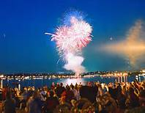

**Our Nations Birthday**

**Let’s Celebrate**

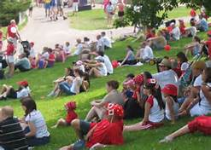

**REGISTRATION FORM**

**(Short Form)**

**Participant(s) Driver:____________________________**

**Co-Driver:_________________________**

**Address:_________________________________________________________________________________________________**

**Phone: ____________________________**

**Email:_____________________________**

**Car Year:____________ Color:__________**

**Emergency Contact: __________________**

**Have you booked your Hotel: Yes / No** (Circle one - If hotel not booked, please confirm back to tour organizer when done at [plsullivan1@sympatico.ca](mailto:plsullivan1@sympatico.ca))

**Hotels must be booked and confirmed by June 1st latest – reference the Trillium Miata Club when making your booking and please book directly with hotel not through web/internet.**

**Hotel Information:**  Best Western Hotel (Fireside Inn) 1217 Princess Street, Kingston, Ontario

Phone: 613-549-2211

Rate: $150.00/night + applicable taxes

Includes full Hot & Cold Buffet breakfast

**KINGSTON 2016**

**-**

**Canada Day Weekend**



Join us for the Canada Day long weekend down in the Kingston Ontario Area. Things will kick off with a Meet & Greet on the Thursday evening in the Hotel Pub. Here we will be able to meet all the other participants and get to relax after the days travel into Kingston by enjoying some pub fare and liquid libation’s.

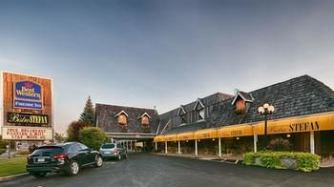

**Best Western Hotel – Fireside INN**

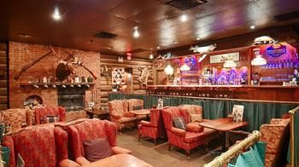

**Hotel Pub – Tom’s Place**

On Friday, we will have an easy morning before we meet at the rallying point for the Kingston Canada Day Parade which kicks off at 11:30 AM sharp and travels several blocks along Princess Street to downtown and ends up at the City Hall. Those participating are requested to ware red and/or white clothing.

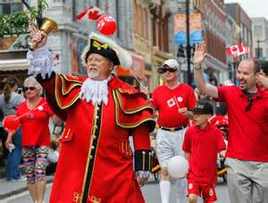 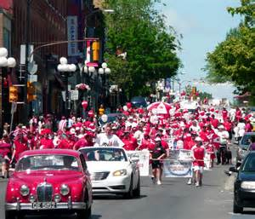

Following the parade, we will regroup and travel, in my opinion, along one of the most memorable routes in Ontario possibly all the way to Westport, where we will more than likely have a midafternoon meal prior to heading back into Kingston. This tour will take us through a series of wonderful roads littered with local and national history. We will take our cars on “Paved Roads” through the local country side, some twisting, some straight, but always with just a hint of adventure. On Friday evening for those who have any energy left, an option is to travel over to Fort Henry for a tour of the facility and also to enjoy the fireworks at about 10:30 from the walls of the fort overlooking the waterfront.

On Saturday we will get an early start and travel along the 1000 Island Parkway to the small tourist town of Rockport, where we will take one of the many boat tours through the islands, possibly stopping off to see Bolt Castle, which is actually US territory and as we would be clearing customs into the US, **you will need your passport**.

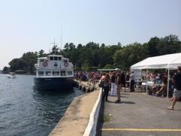 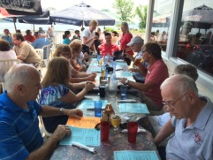

We will follow the boat tour with a light lunch on the upper deck at the Marina restaurant, overlooking the waterway.

We will complete the afternoon with a leisurely tour on roads north of the 401 back to Kingston, arriving mid to late afternoon with sufficient time to enjoy refreshment by the outdoor pool, and for some of us, possibly a short nap before freshening up to head out to our evening meal at Minos Village Restaurant

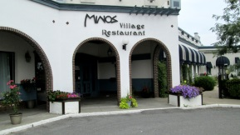 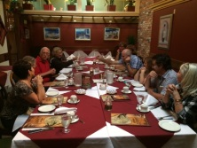

And I can personally attest to the quality of the food. The menu has a little something for everyone.

If this tour is half as enjoyable as it was in 2014, you will not be disappointed.

Register soon!! With the limited size and the buzz surrounding it last time, I expect it to sell out quickly.

Looking forward to seeing you out there

Patrick L. Sullivan

Phone: 519-650-7401

Email: [plsullivan1@sympatico.ca](mailto:plsullivan1@sympatico.ca)

Itinerary subject to change without prior notification