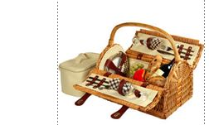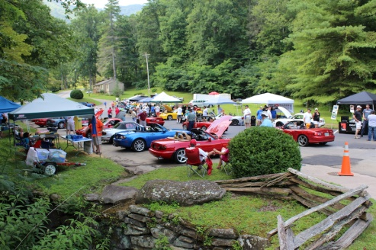

***“SHOW & SHINE & SHENANIGANS & PICNIC PROGRAM”***

10:00 A.M. – OPENING COMMENTS FROM OUR ILLUSTRIOUS PRESIDENT

10:15 A.M. – VOTING FOR SHOW & SHINE CAN BEGIN AND CONTINUE UNTIL 11:30.

ALL BALLOTS SHOULD BE GIVEN TO BERNIE

10:30 – A.M. – LET THE GAMES BEGIN

***During the games make sure you get over to the Show N Shine cars and mark your ballots. After all, that’s why we’re really here.***

(HULA HOOP PRACTICE IS OPEN TO ALL UNTIL THE GAME IS ANNOUNCED)

GAME 1 – LADIES SHOE KICK

GAME 2 – SOCCER BALL KICK

GAME 3 – HULA HOOP ENDURANCE CONTESTS

GAME 4 – BEST BAD HAT PRIZE

GAME 5 – BAD HAT TOSS – hope your bad hat design can fly. Consider Aerodynamics during your design phase.

GAME 6 – WATER BALLOON TOSS

11:45 A.M. – ALL BALLOTS FOR SHOW AND SHINE SHOULD BE IN THE BALLOT BOX

– OR IN BERNIE’S HANDS

12:00 NOON –GATHER IN THE PARKING LOT FOR THE SHOWN & SHINE PRESENTATIONS,

THEN RETURN TO OUR PICNIC AREA FOR 50/50 DRAWS DURING LUNCH

12:15 P.M. – ENJOY YOUR PICNIC LUNCH IN THE COMPANY OF YOUR MIATA FRIENDS.