**25th Anniversary Hoodies & Shirts**

We have now chosen the designs for the Hoodies and Golf Shirts for our 25th Anniversary.

As a special promotion for the clubs’ 25th Anniversary – The club will be paying $20 towards the cost of each item for the first 100 Shirts and/or Hoodies ordered by Trillium Miata Members. The maximum that can be ordered is 2 items per car for the discount. So hurry to get this discount from the club.

After the discount has expired, these items will still be available to order at regular price.

-Mens & Ladies sizes

THE HOODIE

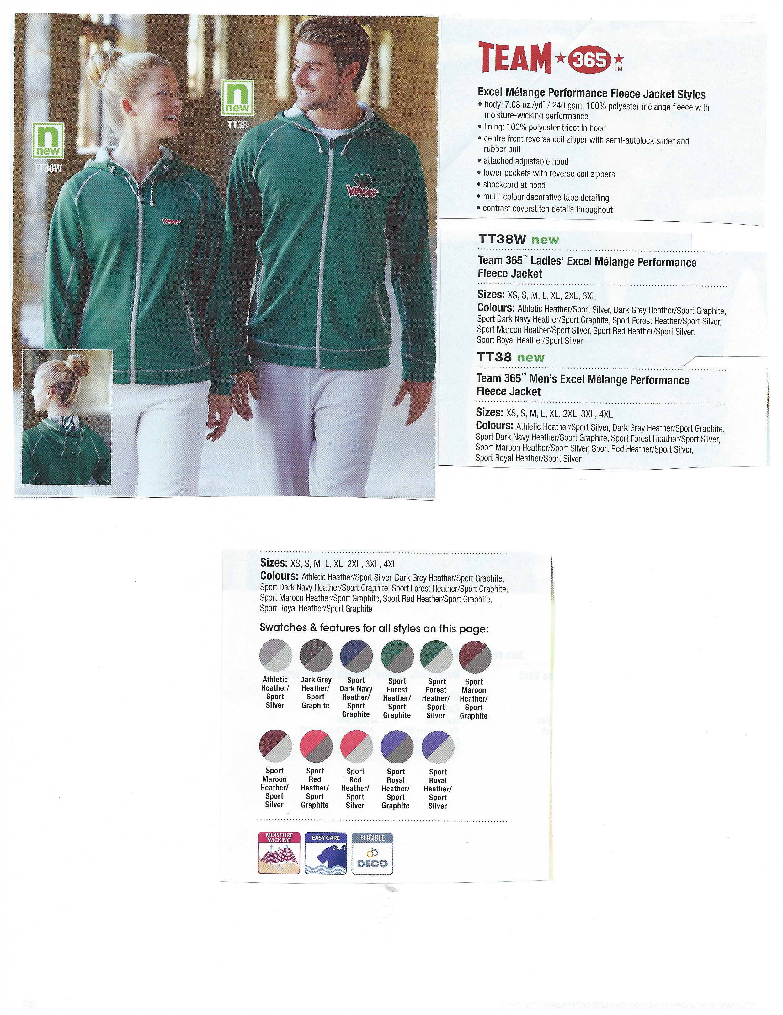

-Soft Fleece, 100% polyester with moisture-wicking performance

-fully lined

-two tone colour on trim and zippers

-attached adjustable hood

-pockets with zippers

-colours

Heather

Dark Grey

Dark Navy

Forest

Maroon

Red

Royal Heather

The Hoodie Specs

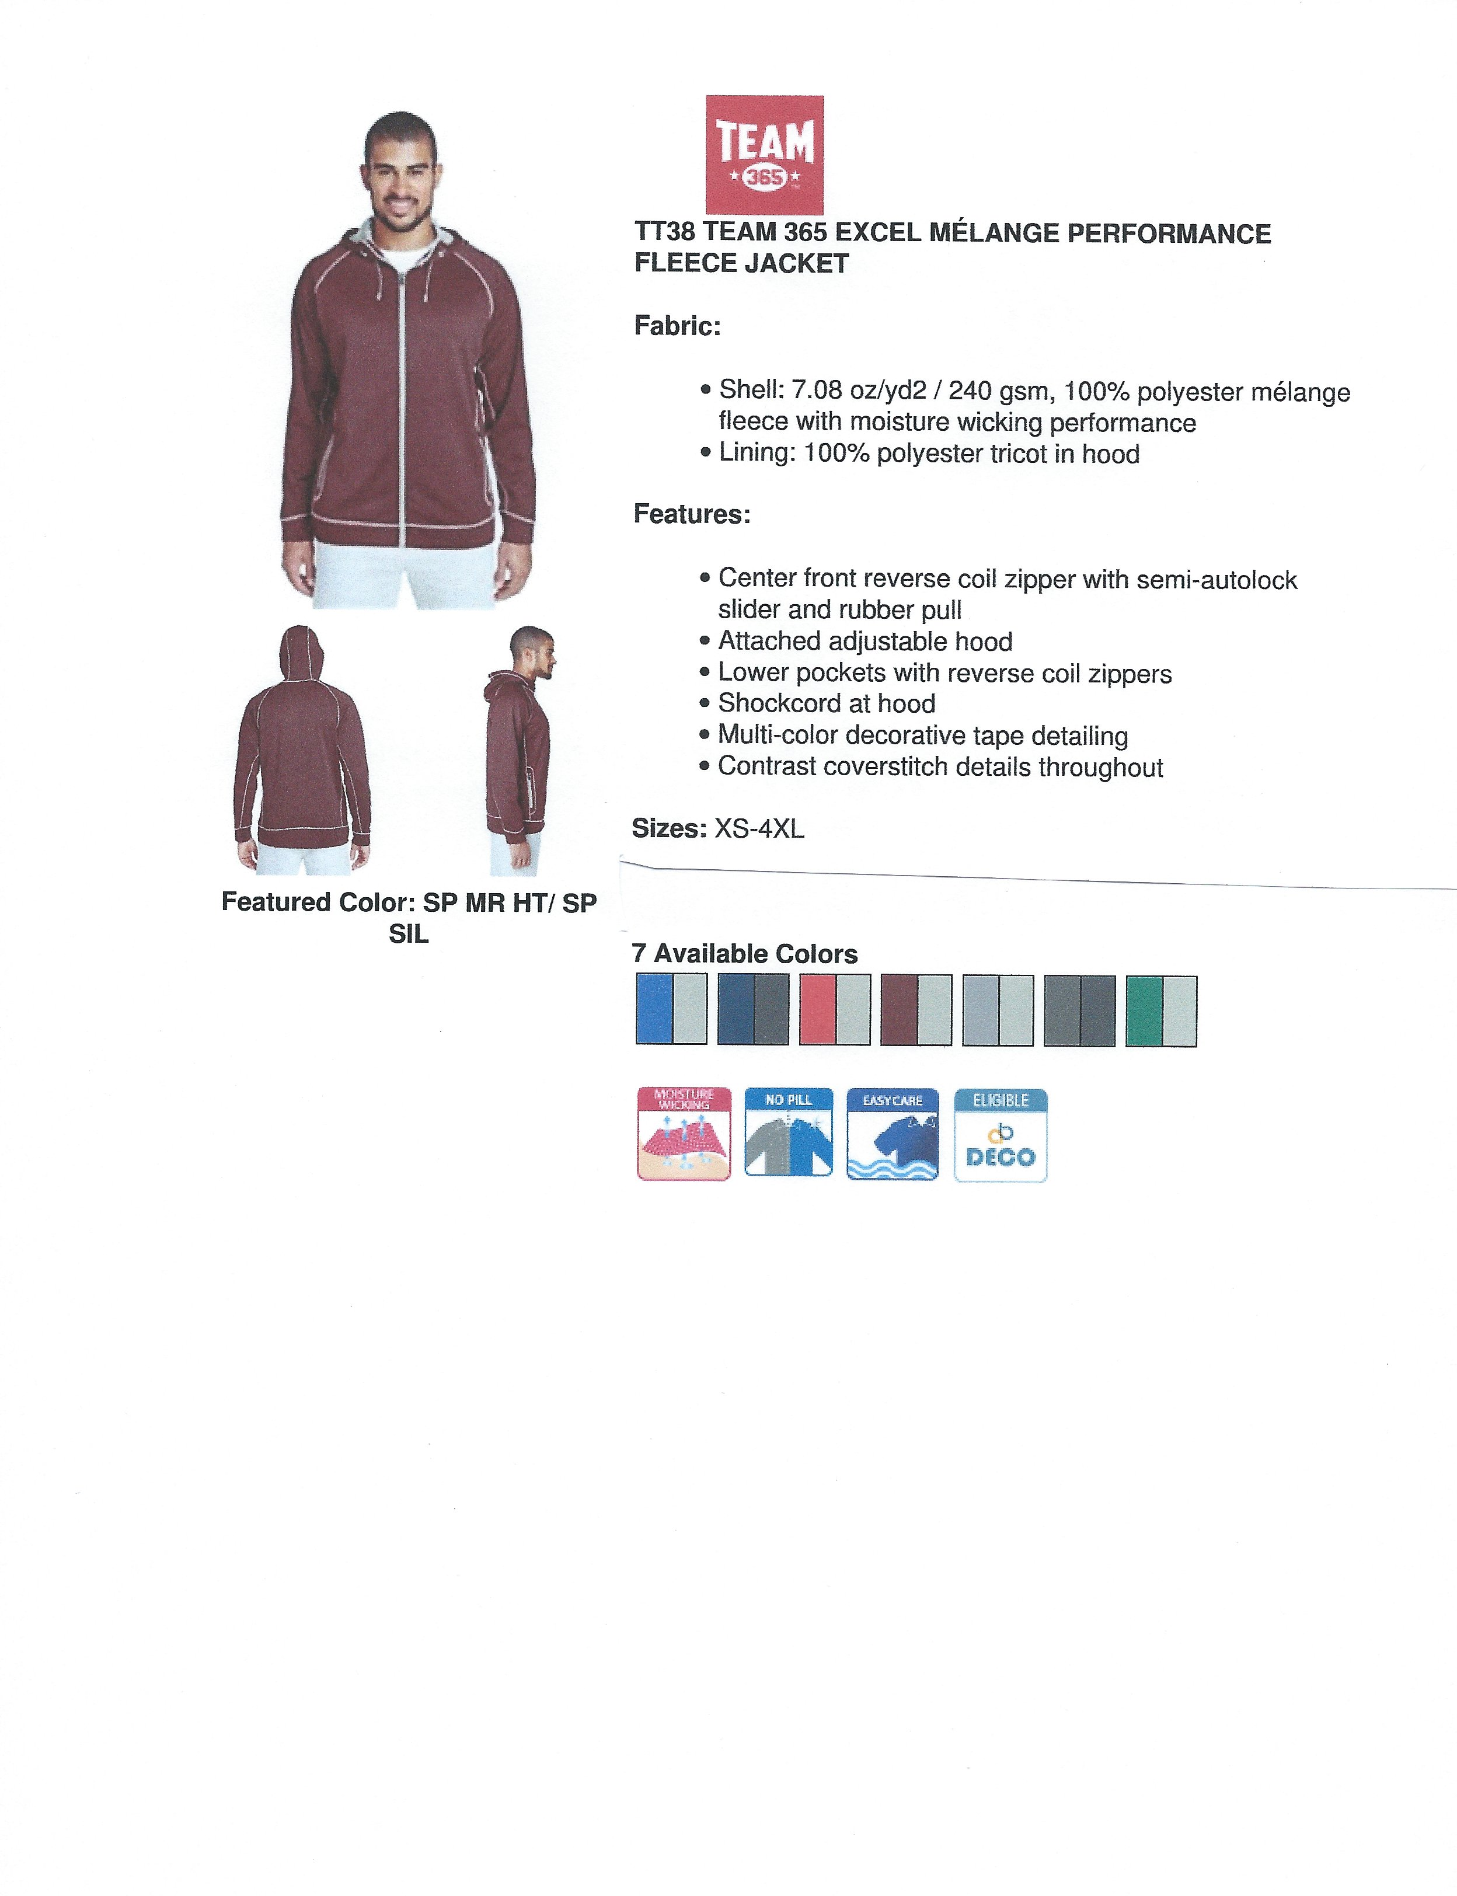

The Hoodie Specs (please note these specs are for the Hoodies only)

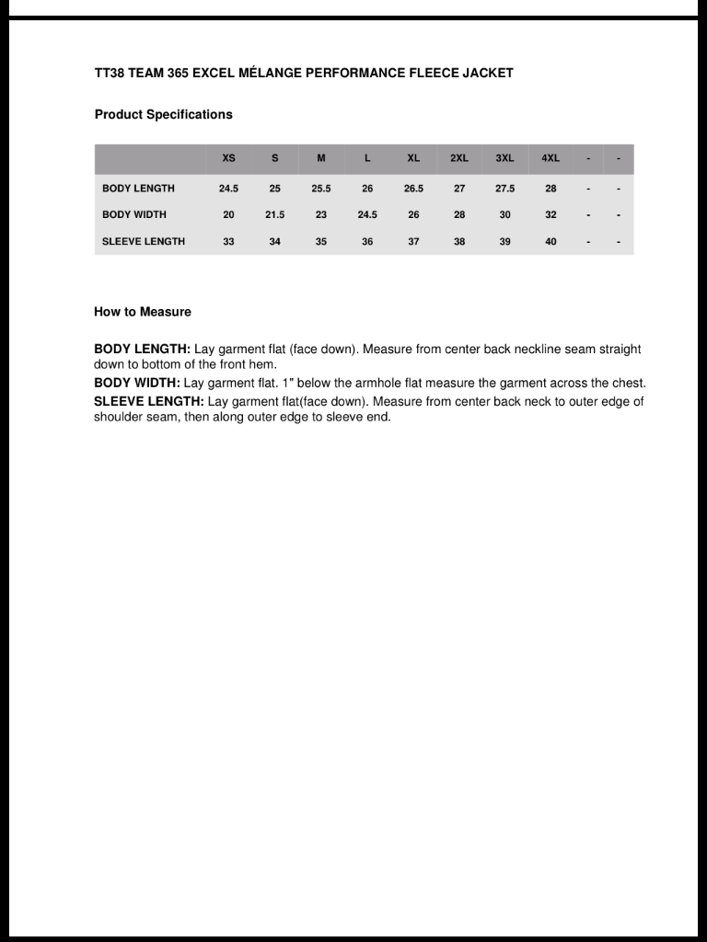

The hoodie will have the 25th Trillium Miata Club logo on the left front. Each item will be personalized with your first name on the right front (maximum 14 characters) – so does Roswithawhat fit? Yes it does. (inside joke, you have to talk to my mother).

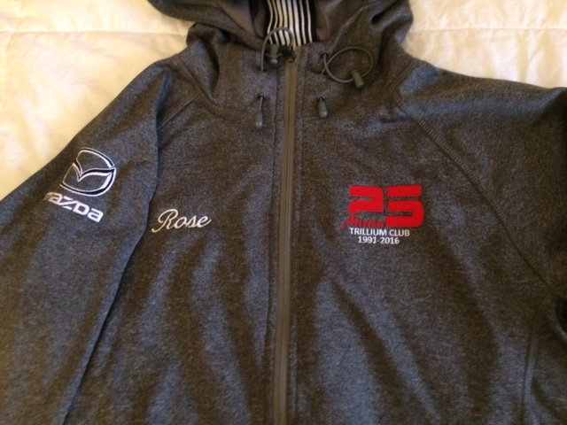

We have changed the colour of the word Miata to RED

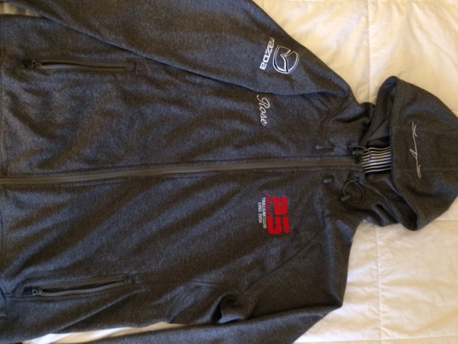

The Hood will have the roaster outline on it so it shows when the hood is up or down. The Roadster will be White.

As well the Mazda Canada Logo will be on the right sleeve.

Cost of Hoodie: $75.00

Club Discount: $20.00

$55.00

Taxes: $7.15 (yes you get a break of $2.60 on the taxes)

Cost to Member: $62.15 each

After Discount expires the cost will be $75.00 + tax of $9.75 = $84.75

**We will also be**

**offering Golf Shirts.**

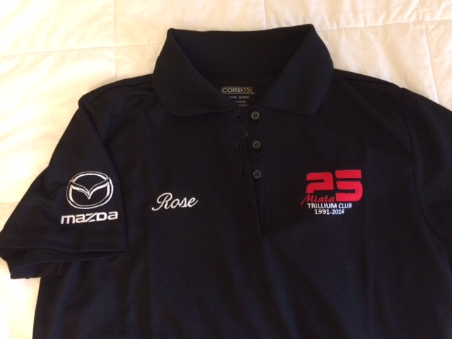

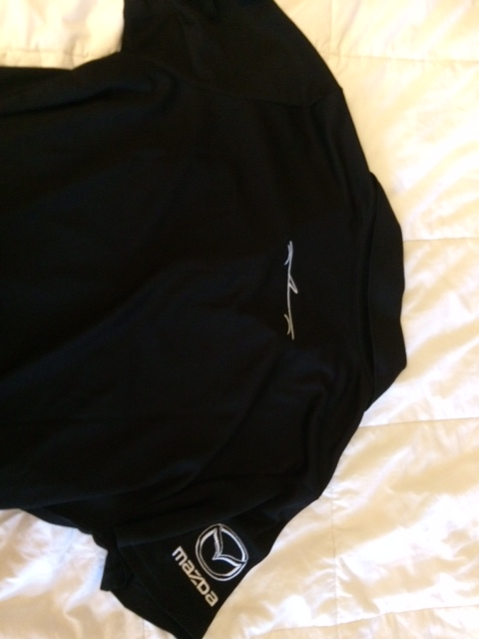

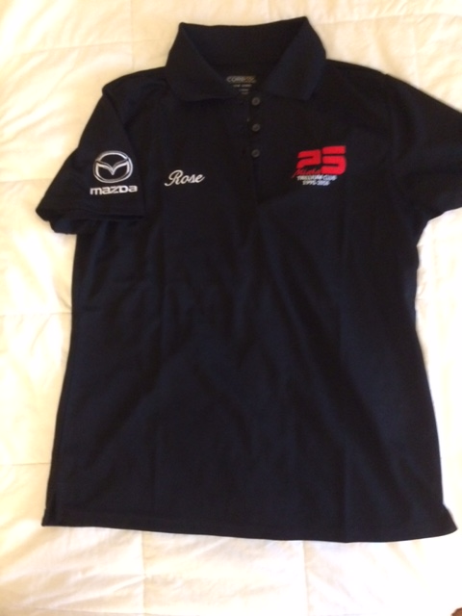

Golf Shirt Colours & Specs

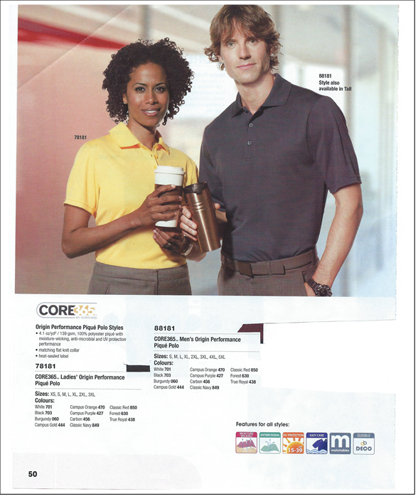

Golf Shirt Colours

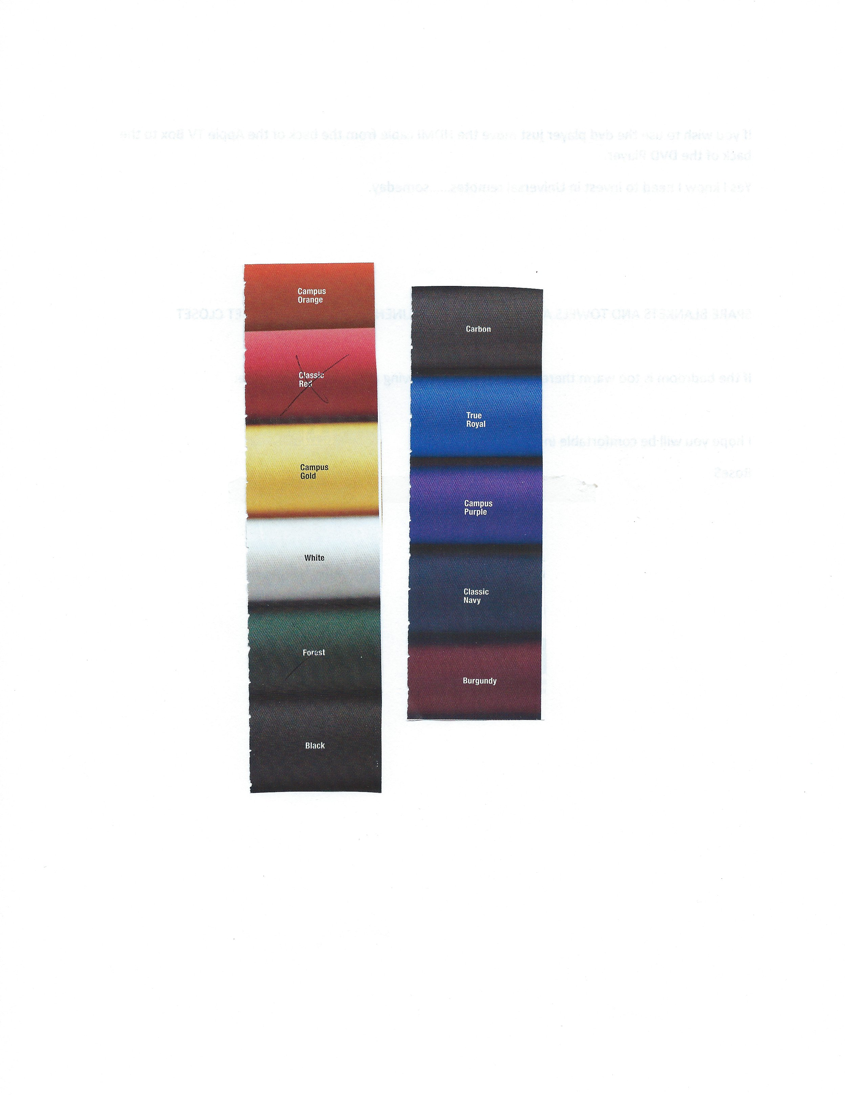

The Features of the golf shirts are:

* Origin Performance Pique Polo Style from Core 365
* 100% Polyester pique with moisture-wicking, anti-microbial and UV protection
* Wrinkle free, quick dry fabric – great for travelling
* Sizes are XS, S, M, L, XL, 2XL, 3XL in both Mens & Ladies cuts.
* Colours: White, Black, Burgundy, Campus Gold, Campus Orange, Campus Purple, Carbon, Classic Navy, Classic Red, Forest, True Royal
* Customized embroidery will be the same as the Hoodie

Cost of Shirt: $35.00

Club Discount: $20.00

$15.00

Taxes: $1.95 (yes you get a break of $2.60 on the taxes)

Cost to Member: $16.95 each

After Discount expires the cost will be $35.00 + tax of $4.55 = $39.55

***** COLOUR CHOICES: Remember the colours we are using for the embroidery – Red and White – this may help you in your colour choices of shirts and hoodies.

Also – based on this presentation, you do not want me in charge of Marketing or Brochures – my cut, paste, scan skills are pretty pathetic…. RoseS

See order form below. You can email me an order form or simply send me an email with details of your order.

VP@trilliummiata.ca

Phone: 289 238 8951 – call if you have any questions.

Payment methods are:

Visa & Mastercard –       you much phone me with your credit card number.  I do no recommend sending your financial information via email.  Trillium Miata will process your payment and email a confirmation receipt to you.  Please call me at 289 238 8951.

Cheque:                              Payable to Trillium Miata Club and mailed to me or bring it to the next meeting:

                                             Mail to:  Rose Stipanitz, 360 Park St., W., Dundas, Ontario L9H 1Z4

Cash:                                   Brought to a meeting.

Order will be placed with the supplier on Oct 31, 2016.  I am not sure of delivery date yet, but will advise. A second order will probably be placed at the end of November, but by then the discounts may be gone.

Please advise your choice of payment.

Trillium Miata Order Form 25th Shirts & Hoodies

Name: ________________________________________ Phone: _________________________

Email: ________________________________________________ Order #: ___________________

(send order form to Rose Stipanitz – vp@trilliummiata.ca) (max 2 items per car for discount price)

|  |  |  |  |  |  |  |  |
| --- | --- | --- | --- | --- | --- | --- | --- |
| Code# | Description | Colour | Size | Printed Name on item | Qty | Price | Total |
| TT38W | Hoodie – Woman  Sizes: XS,S,M,L,XL,2XL,3XL  Colours: (Body/Trim)   1. Athletic/silver 2. Dark Grey/Graphite 3. Dark Navy/graphite 4. Forest/graphite 5. Forest/silver 6. Maroon/graphite 7. Maroon/silver 8. Red/graphite 9. Red/silver 10. Royal/graphite 11. Royal/silver |  |  |  |  | With Discount:  $62.15  Without Discount:  $84.75 |  |
| TT38 | Hoodie – Mens  Sizes: XS,S,M,L,XL,2XL,3XL,4XL  Colours: as above |  |  |  |  |  |  |
| 78181 | Golf Shirt – Woman  Sizes: XS,S,M,L,XL,2XL,3XL  Colours:  701-White  703-Black  060-Burgundy  444-Gold  470-Orange  427-Purple  456-Carbon  849-Navy  850-Red  630-Forest  438-Royal |  |  |  |  | With Dicsount:  $16.95  Without Discount: $39.55 |  |
| 88181 | Golf Shirt – Mens  Sizes: S,M,L,XL,2XL,3XL,4XL,5XL  Colour as above |  |  |  |  |  |  |
|  |  |  |  |  |  |  |  |