**25th ANNUAL TRILIUM MIATA AWARDS**

At the next Blah’s Bash in February 2017, the club is reinstating the tradition of handing out special awards to members who have done something unique, silly, interesting or just plain fun; over the **last 25 years**. The highest award to be given is the coveted Golden Brick Award.

I would ask each and every one of our members to check out the list of awards below and send your nominations to VP@Trilliummiata.ca.

Each nomination should include:

* the name of the award,
* the nominee,
* a brief story of the event which has led to the nomination,
* and a picture would be great.

Nominations will be tallied and voted on and the awards will be presented at our Blah’s Bash.

The deadline for nominations is January 15th, 2017, so there is still lots of time this season to gather data on new possible nominees, and review what has happened over the last 25 years!

**The Coveted Golden Brick Award**

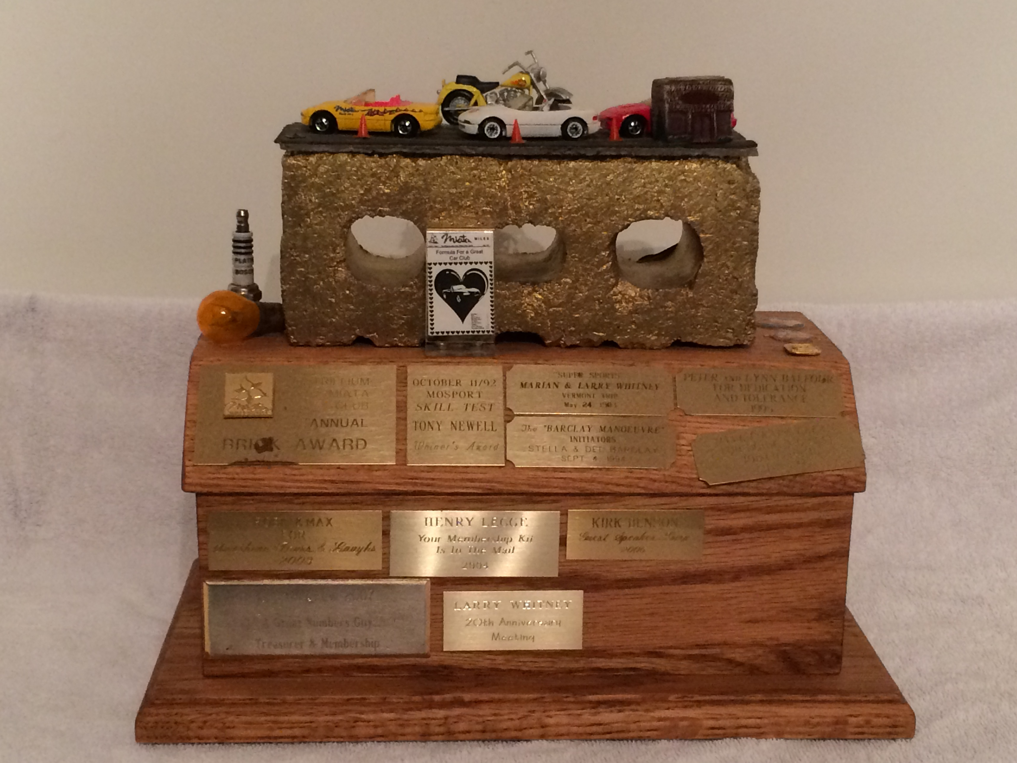

**The Official list of Awards**

**The Golden Brick**

Award given for just about anything that isn’t covered in other awards.

I am submitting nominations for pictures of the most number of Trillium Miata members on a hotel bed. So far there have been 2 nominations with supporting photographic proof.

**Most Unlikely co-driver**

Current nominations include Michael Darragh for the buzzard that landed on his passenger seat. With a convertible you never know what’s going to end up in your car.

**Best Car Picture**

I’m looking for lots of pictures to review for this one.

**Worst Car Picture**

Get creative – review all your pictures and send them in. Or take some new bad pictures.

**Worst Picture Nomination**



**The Great Garmin Award**

We all have a Garmin story. Share the stories, send in your nominations.

**The Golden Horseshoe Award**

Most U-Turns made while attempting to win the Great Garmin Award. I am currently nominating myself for this one. On the Vermont tour this year I think I led 10 U-turns in one run.

We can’t do this justice without your help. Nominate (or embarrass) your friends. Have some fun with this.

Thanks

Rose Stipanitz, VP

vp@trilliummiata.ca