**Now Open for registration**

**July 2017**

**The**

**Carling Lake Canada Day**

**Weekend Tour**

This tour will be based out of the Carling Lake Hotel ( <https://hotellaccarling.com/en/> ) 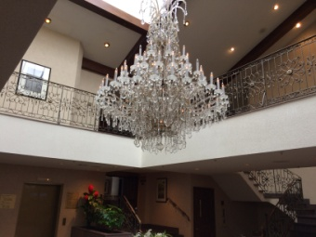 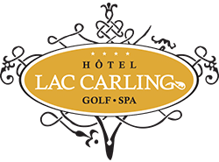 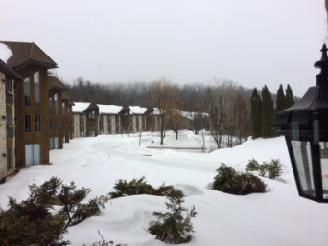

approx. an hour from Montreal, an hour and a half from Ottawa and 30 minutes or less from both Lachute Que. and Hawkesbury Ont., from Friday night June 30th through to Monday AM July 3rd.

The hotel has recently gone through a multiyear renovation project and looks fabulous. All of the guest rooms have scenic views overlooking the hotel owned golf course. The rooms we have reserved, are all basic rooms and on the main level complete with walkouts. (Note: room upgrades are available for an added cost) There are two bars, one overlooks the indoor tennis courts where as the second is just off the main lobby. There is also an onsite restaurant with scenic views of the lake and hills. Other amenities include a squash court, and gym. All of which are free of charge to those staying at the hotel. So if for example your interested in a friendly tennis match, bring your racket.

With the lake right at the hotel, those interested could rent a canoe or pedal boat through the hotel and venture out for a relaxing excursion on the water.

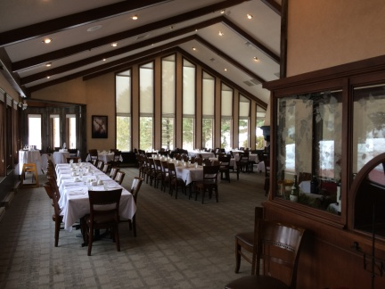 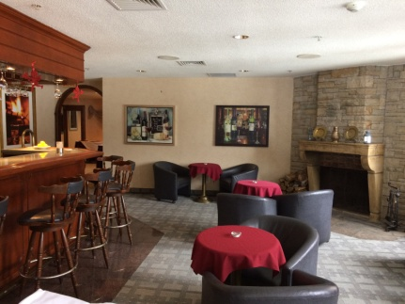

Similar the our 2016 Kingston Tour, the basic agenda would cover participants making their way to the resort on the Friday where we would have a meet & greet in one of the bars that evening, tour the Laurentian’s up to Mont Trembent on the Saturday and then Sunday would cover a drive to St Sauver for lunch, followed by another leisurely drive to Hawkesbury where we would have a simple complimentary BBQ at our home.

For those not interested in heading out during the day for the drives, there is also the hotel owned golf course on site for an extra cost with rental clubs available or relax at the indoor pool which has access to an outdoor patio. Or even partake of the Wellness & Spa center enjoying a massage or even a sauna.

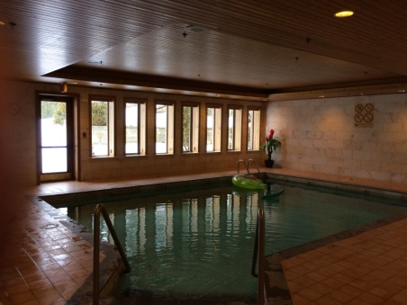 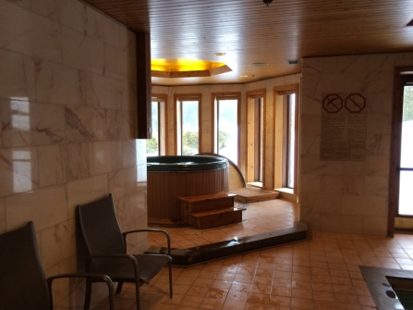

This tour will be limited to 10 vehicles and as this is a new tour, there will be a very short window for registration.

**Till then, happy touring!!!!!**

**Tour Organizers: Patrick Sullivan & Yves Robert**

If interested in this tour, email your completed registration form to Patrick Sullivan @ [plsullivan1@sympatico.ca](mailto:plsullivan1@sympatico.ca) without delay.