**Ok we all agree that was a “3”**

Trillium Miata Club

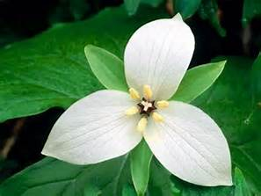



2017 OPEN GOLF TOURNAMENT

Building on the success of the 2016 inaugural event, we have booked the “Classic Nine” course at Doon Valley Golf Club in Kitchener for the 22nd of July, 2017. The tournament will continue to be in the Kitchener/Cambridge area. The course is easily accessible and provides all the amenities that we are looking for.

**A course layout suitable for all skill levels / Banquet facilities / Club Lounge**

**Location in close to hotels / Shopping and other activities close to course**

We will also retain the same winning format of a 9 hole best ball program followed by a meal and awards presentation. This year however the meal will be at the golf course in one of the banquet rooms. And, is open to non golfers and members guests to attend as well.

For 2017, we will be looking for a minimum of 20 golfers to a maximum of 32. However there is no restriction on the number of diners. But both types of attendees need to complete the registration form. Trillium members can also invite guests to the tournament as well as to the banquet. However, only golfers will be eligible for any prizes and awards. Remember this is a fun tournament and your ability on the golf course is irrelevant.

**FORE!**

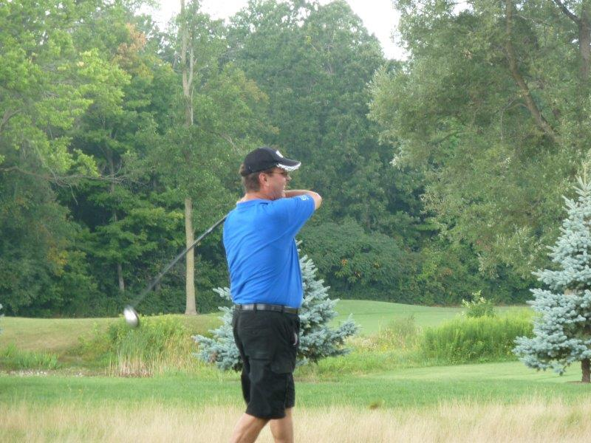

**Head Down…**

**

**Aim…**.

**