**Ontario’s South Coast Fall Tour**

**Sat Sept 23, 2017**

Come and explore Ontario’s South Coast on this fall tour and Celebrate Canada’s 150 Birthday. This will be a leisurely tour with informative talks at various historical spots along our route.

St. Williams Conversation Reserve

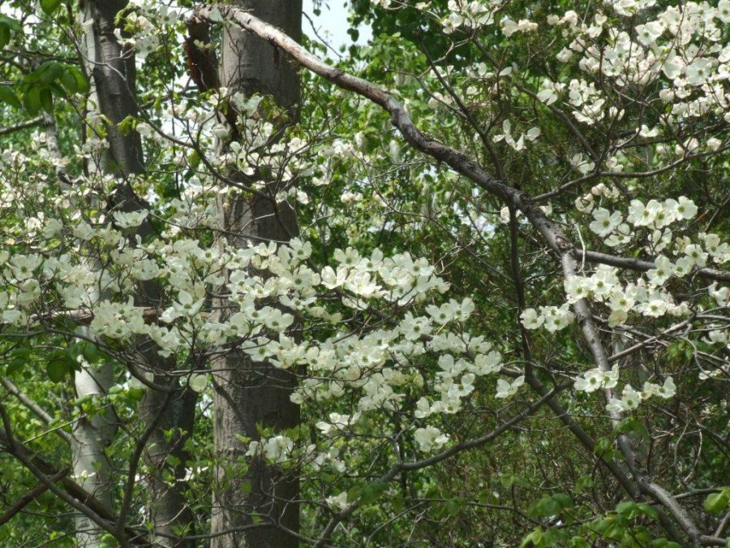

St. Williams Conversation Reserve

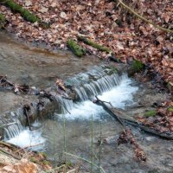

The Tour will start at Tim Hortons in Jarvis with a driver’s meeting at 9:45 a.m. and 10:00 a.m. departure. The Tim Hortons is located on Hwy #6 in Jarvis, Ontario. 2021 Main ST., N, Jarvis, Ontario, NOA 1J0. You can’t miss it, Jarvis isn’t that big. Depart at 10:00 a.m. Anticipated conclusion: 3:30 ish.

The tour will stop for brief informative talks as well as a chance to get out of your car and stretch at: Nanticoke Generating Station, US Steel, Port Dover (home of Friday 13th Motorcycle Rallies), Port Ryerse, and Spooky Hollow, Turkey Point, St. Williams Conservation Reserve & ST. Williams Provincial Forest Station.

Bagged Lunch at Burning Kiln Winery

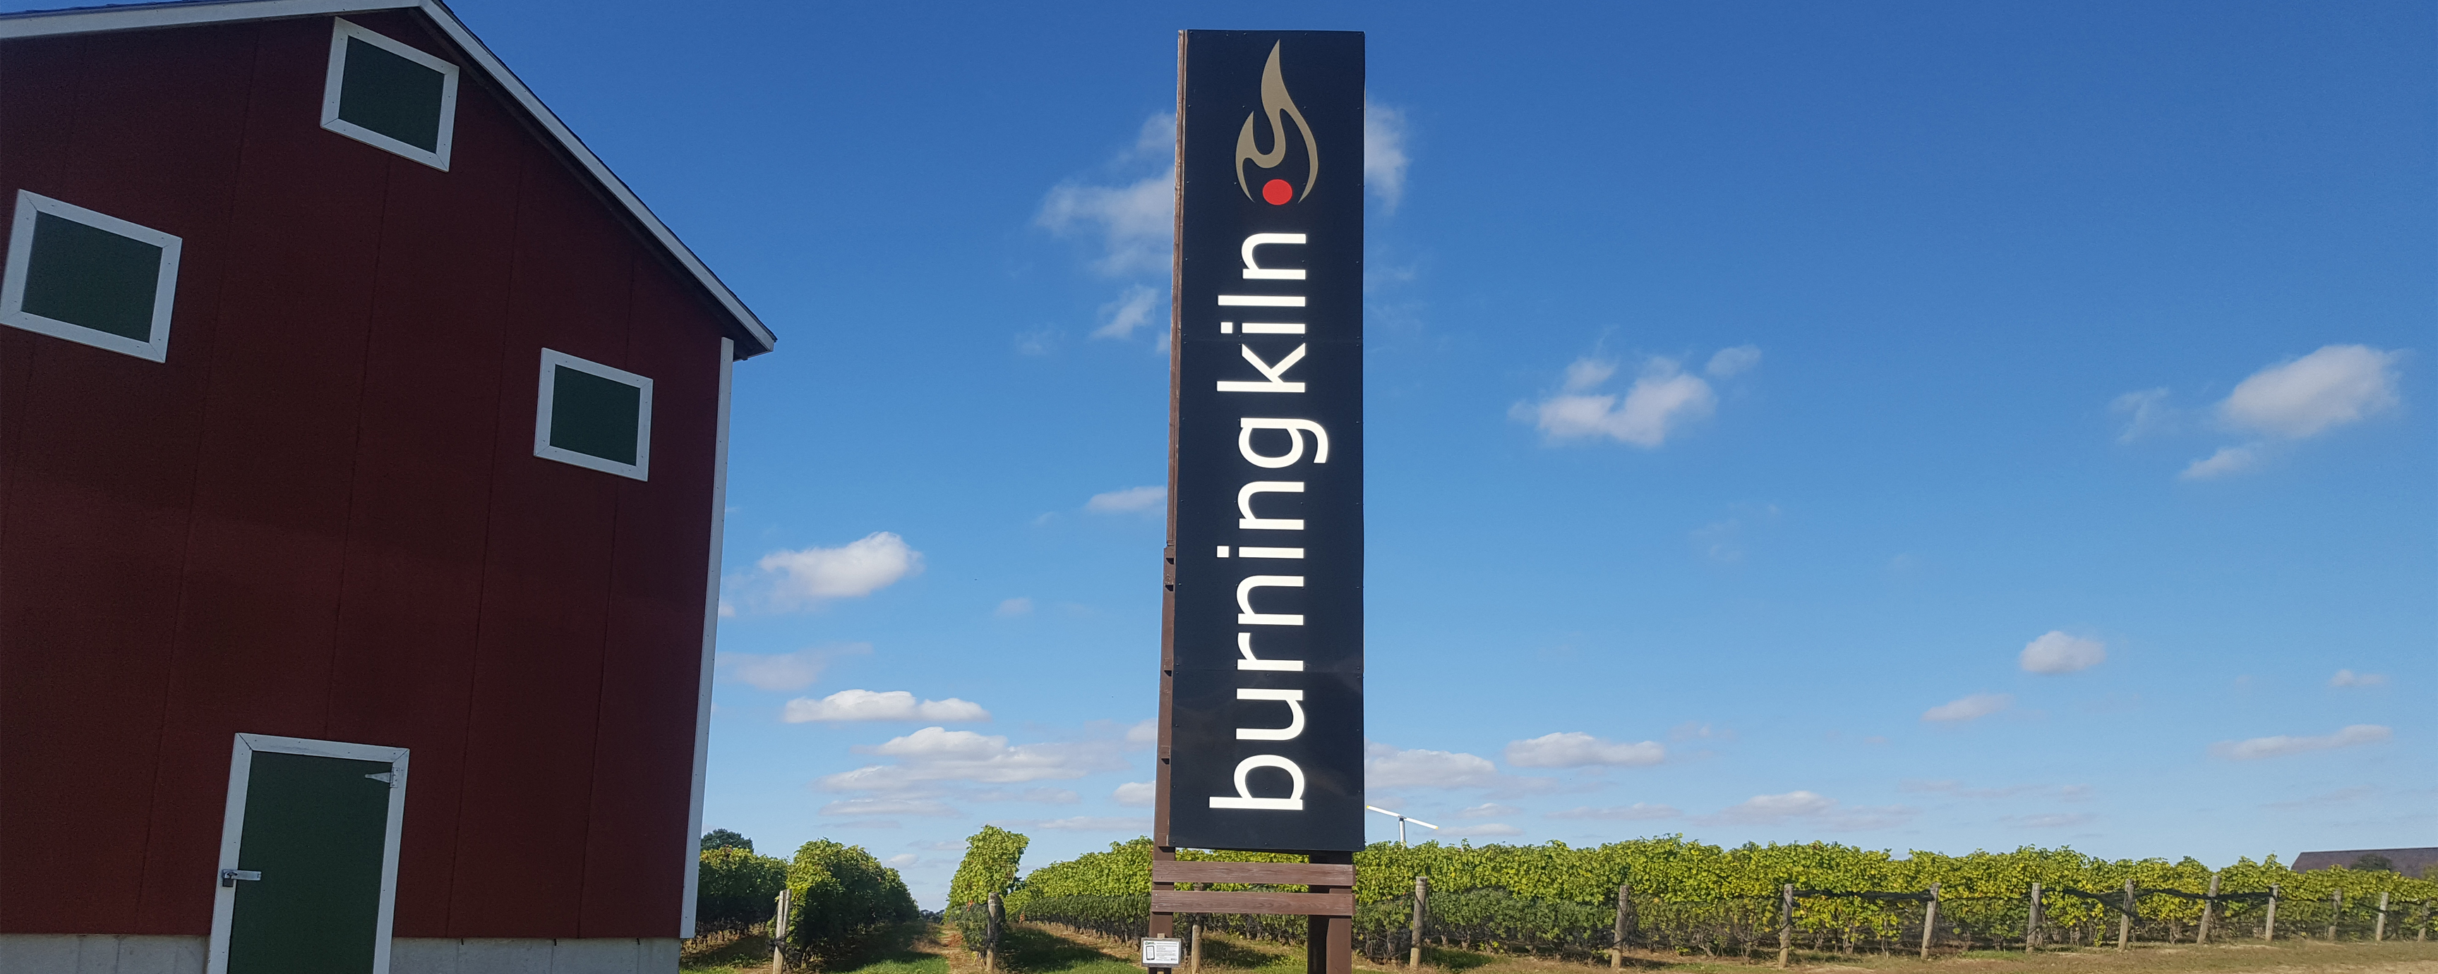

We will be lunching on the Patio of the Burning Kiln Winery. A bagged lunch is available to be purchased on our webpage as there is no restaurant on site. You will also be given time to take a tour of the winery. Cost for lunch is $15 pp. Cost for Wine tour is $10 pp.

If you prefer to skip the wine tour part of this stop, join Steve Williams, our club tour guide; of the area at a local ecology conversation area. We will all meet up again at the winery before we continue our tour to the ST. Williams Provincial Forest Station Museum. Home of the first provincial tree nursery established in 1908 which to celebrate Canada’s 150th is featuring an exhibit of sawmills of yesterday. This is where the tour will end so you can have as much time as you want to enjoy the museum and a nature walk.

Your tour guide is Steve Williams who became a member of the club last year having purchased a silver 2015 Miata. Steve moved to the area from Cochrane in the later part of the last century and retired from the position of Management Forester here with the Ministry of Natural Resources and Forests several years ago.

Steve knows some hidden features and treasurers of the area that last years participants might not have seen.

Please join us if you can….. RoseS & Steve Williams