**2018 Blah’s-Bash Sat. Feb.3th.**

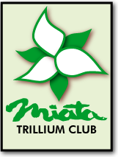

**The annual Blah’s Bash is a mandatory mental health exercise that we all need.**

**We’ve missed our cars and our friends as winter is upon us.**

**Don’t give up hope – reminisce last season, talk about the next season.**

**Great dinner + Socializing + Nice Hotel venue + a little Music = Good times**

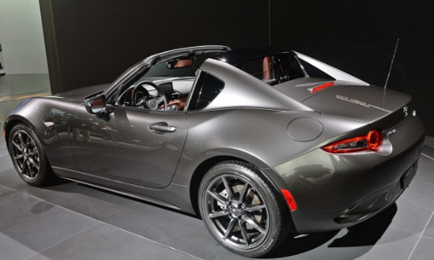

**You could also Win a New MX-5 RF for a week?**

**sheraton PARKWAY TORONTO north HOTEL & SUITES**

600 Highway 7 East, Richmond Hill, ON L4B 1B2

The cost of the venue will again be subsidized by the Club

**Your cost is $40 ea. / Members, Friends & Family**

This includes a top notch 3 course Buffet Dinner plus desert; 2 complementary Alcohol drinks per person, & unlimited soft drinks.

Doors open at 6:00pm. Dinner at 7:00pm

**Hotel (optional)**

Best Western traditional room @ $119.00

Sheraton traditional room @ $139.00, premium room @ $149.00, premium suite @ $164.00

All the rates above are subject to 16% tax and fee.  Call 1-800-668-0101 to reserve your room. Mention Trillium Miata event in order to get this group rate.

**This venue has limited seating and ALWAYS sells out quickly.**

**Registration will be closed Jan 30th.**

**You can pay online Via our Web Site, by Cheque at the Nov Dec & Jan. meetings or mail cheques to**

Rose Stipanitz (289) 238-8951

360 Park Street West

Dundas, On, L9H 1Z4 Cheques should be made payable to “**Trillium Miata Club**