**Trillium Miata Club - 2018 New York/Vermont Weekend (New Town! New Hotel!)**



***Friday, May 18 to Monday, May 21, 2018***

**WHERE ARE WE STAYING?**

For 2018 we will be staying at an exciting new hotel venue and will be based in a new town; **The Lake House:** 1 Mirror Lake Drive, in downtown **Lake Placid, New York** (part of the High Peaks Resort complex) [www.highpeaksresort.com](http://www.highpeaksresort.com)

**The Lake House** has only 44 rooms available and the entire Hotel is available for our event if we can fill it. It is located right in the heart of downtown Lake Placid. Mirror Lake is steps away, with complimentary boats to use, on-site restaurants, recently renovated guest rooms and 4-star guest service with spectacular views. Walk out the front door to all of the shops, restaurants, galleries and Olympic offerings of Lake Placid (Host City of the 1932 and 1980 Winter Olympics).

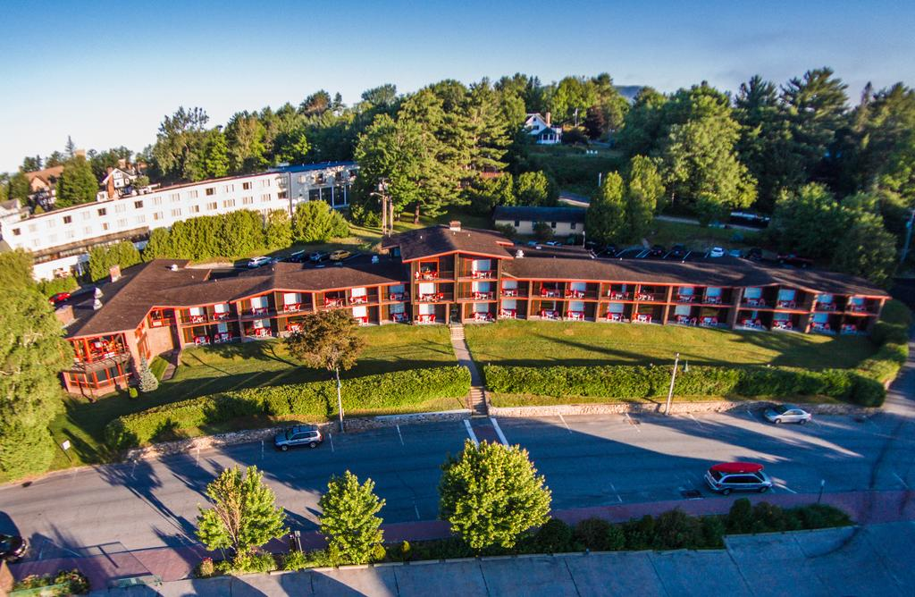 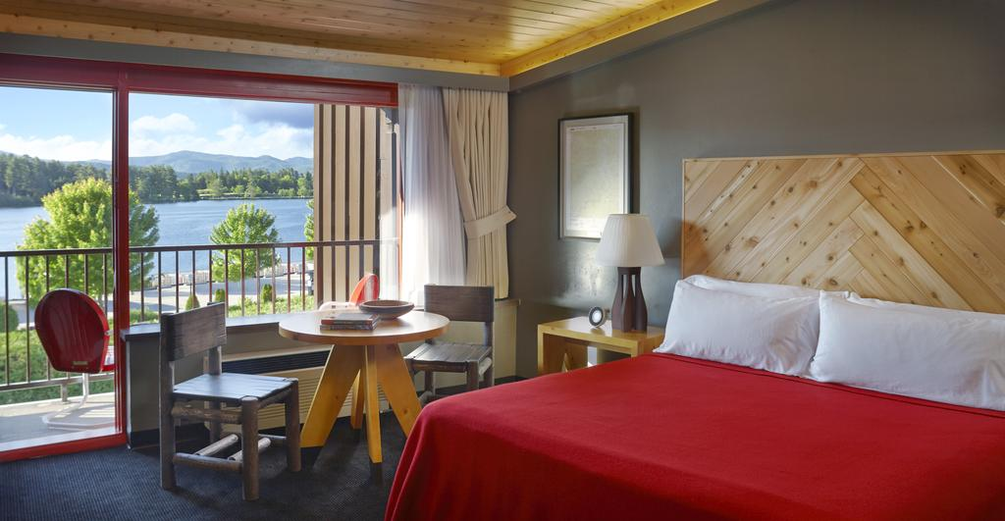

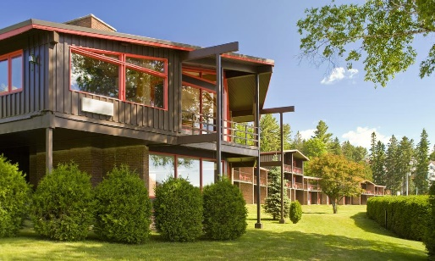 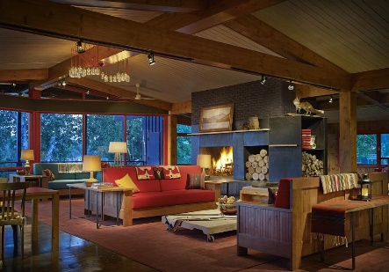 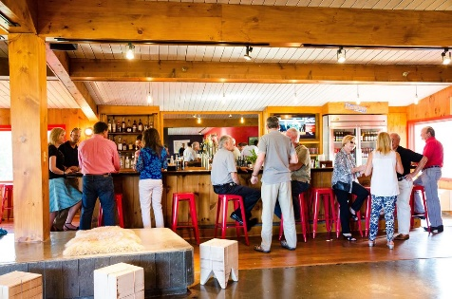

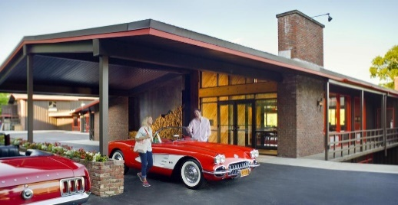 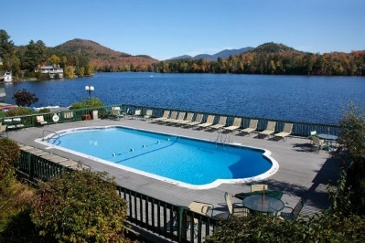 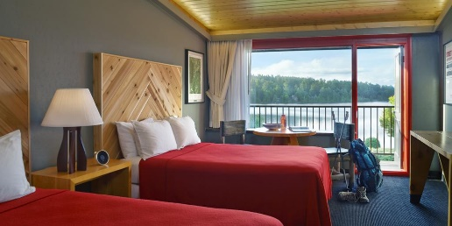

*Photos courtesy of High Peaks Resort/Lake House*

Lake House guests have several pools for their guests to use and Whiteface Mountain and Mt. van Hoevenberg are an easy 15-minute drive away. **Lake House guests have the full run of the amenities of the High Peaks Resorts complex.**

**THE ROOMS**

**The Lake House has 1 price category of rooms with the differences between them being beds and balcony/walkout formats**. Of the 44 rooms, 8 rooms have “King Size” beds, 32 rooms have 2 “Queen Size” beds, and 4 rooms have 1 “Queen Size” bed. As we have in previous years, you will be asked to specify your #1, #2 & #3 choices of rooms when you register with Tour Leader Gary Svoboda.

|  |  |  |  |  |  |  |  |  |  |
| --- | --- | --- | --- | --- | --- | --- | --- | --- | --- |
| **Room Category** | **# of Rooms Available** | **Room Rate Per Night**  (all costs in US dollars) | | | | | | | **Closing Sunday Dinner**  **($US - NOT optional) (taxes & gratuities extra)** |
| Wed May 16 | Thu May  17 | **Fri May**  **18** | **Sat May**  **19** | **Sun May**  **20** | Mon May  21 | Tue May 22 |
| Upper Level – King | 3 | 119 | 119 | **145** | **145** | **145** | 119 | 119 | $44.00 per person |
| Upper Level – 2 Queen | 15 | 119 | 119 | **145** | **145** | **145** | 119 | 119 |
| Upper Level – 1 Queen | 2 | 119 | 119 | **145** | **145** | **145** | 119 | 119 |
|  |  | 1 |  |  |  |  |  |  |
| Lower Level – King | 3 | 119 | 119 | **145** | **145** | **145** | 119 | 119 |
| Lower Level – 2 Queen | 15 | 119 | 119 | **145** | **145** | **145** | 119 | 119 |
| Lower Level – 1 Queen | 2 | 119 | 119 | **145** | **145** | **145** | 119 | 119 |
|  |  |  |  |  |  |  |  |  |
| Third Level – King | 2 | 119 | 119 | **145** | **145** | **145** | 119 | 119 |
| Third Level – 2 Queen | 2 | 119 | 119 | **145** | **145** | **145** | 119 | 119 |

* **Most Upper Level Rooms have balconies, most Lower Level Rooms have walkouts.**
* **Nights in yellow are compulsory. $145 is the average nightly rate for the 3 nights. Actual nightly rates will vary on your bill.**
* **Breakfast is additional and on your own, available from 7 am at the Dancing Bears Restaurant located in the Main High Peaks Resort Tower, or elsewhere if you wish. Plan to be in the Hotel Parking Lot by 8:30 AM for the daily tour briefing.**

**UNDERGROUND MIATA NETWORK**

Again for 2018, **Ottawa/Hull Underground Miata Network** members are invited to participate. UMN members will be required to complete the same application form and registration process along with TMC’s Hold Harmless Form.

**WEST PENN MIATA CLUB**

This year, we will be again inviting the **West Penn Miata Club** to also join us for the New York/Vermont Tour. West Penn members will be required to complete the same application form and registration process along with TMC’s Hold Harmless Form.

**PARTICIPATION REQUIREMENTS**

* **All Participants on this Tour MUST stay in the Lake House Friday night, Saturday night and Sunday night.**
* **Must be active member of Trillium, UMN or West Penn Clubs at the time of the Tour.**
* **UMN & West Penn members must return TMC Hold Harmless form with registration.**
* **Your Miata must be in good mechanical condition.**
* **You must have a working CB radio in the car.**
* **There is a mandatory $Cdn 30 per person ($25 US) registration/gear fee**

**EXTENDED STAY OPTION:** For any members who would like to enjoy Lake Placid a little longer, the Lake House is offering an even lower reduced rate for the 2 days before and the 2 days after our tour, based on availability at time of booking ($119/night).

**DEPARTURE POINT:** As in pervious years, we will be offering the option to members of driving in a group, departing from Kingston Thursday and Friday morning (Location TBA). Or, you can organize your own groups or come down individually.

**DAILY TOURS:** On the Saturday and Sunday there will be tours of the New York & Vermont countryside and lunch locations will be arranged. Each day’s tour will end at the lunch location leaving the afternoon free for sightseeing, shopping or relaxing. Once again, there will also be a Friday Early Bird Tour. All tours are once again being researched and mapped out by Tom Brown, our Trillium Miata Club member from Vermont.

**Sunday - CLOSING DINNER:** Our traditional closing dinner will take place in on Sunday, May 20th. Dinner will be a buffet and will include appetizers, soup or salad, entrées and desserts. This dinner will cost $44 per person (plus taxes and gratuities). This dinner is part of the package and is NOT optional. The hotel will in all cases automatically charge the dinner to each participant’s hotel bill.

**NEXT STEPS:** Please complete & submit the **Registration Form** along with your **$30 CDN/$25 US registration fee to Gary Svoboda** at [mazda.liaison@trilliummiata.ca](mailto:mazda.liaison@trilliummiata.ca). For questions, call Gary at 519-824-7456. Or complete the information and submit electronically through the website.