**Canada Day**

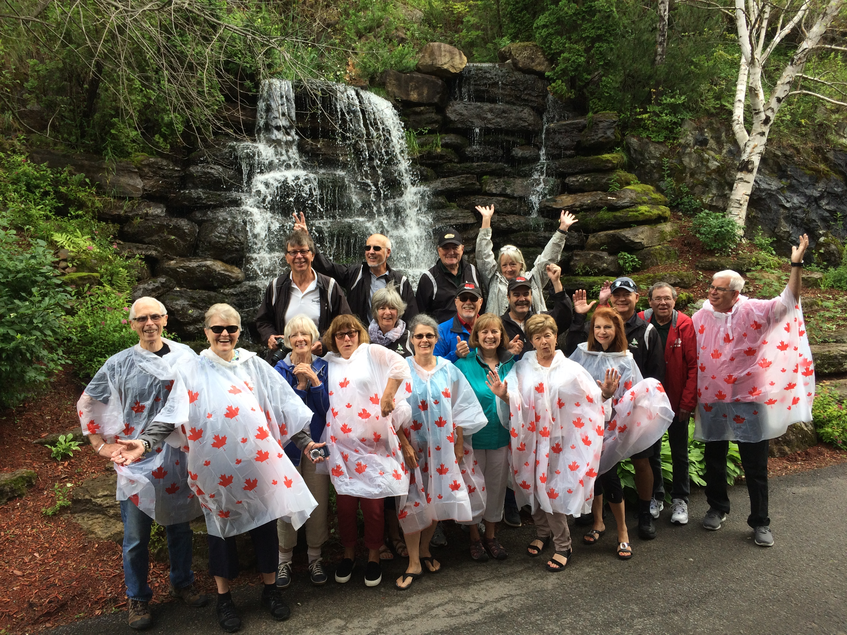

**Weekend Tour**

**2018**

Planning is almost completed for the 2018 Canada Day Weekend tour which will be held from the evening of June 29th to the morning of July 2nd.

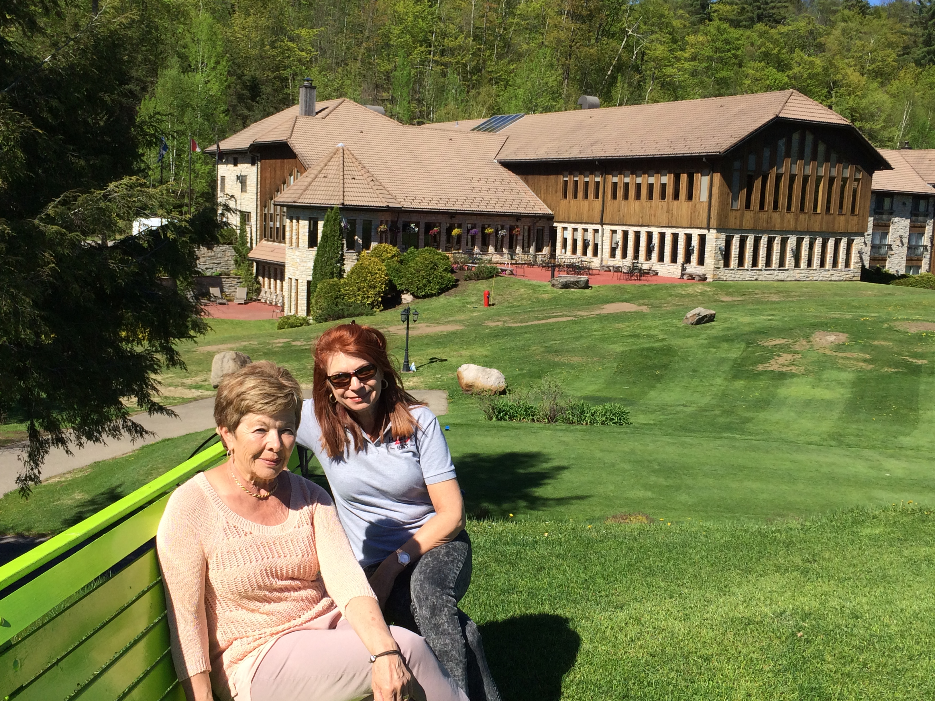

The tour will again be based out of the Carling Lake Hotel, Golf & Spa resort in Pine Hill Quebec, located only an hour from Montreal and 1.5 hours from Ottawa. The tour will consist of a variety of new & previously toured roads and amazing daily destinations & activities.

Intense negotiations are already underway with Mother Nature to ensure the best possible weather conditions for this event.

Official registration is expected to open no later than March 10th, 2018. The target number for this repeat tour is 20 cars and based on recent conversations, I expect that the tour will book up quickly once registration begins. Registration will close May 15, 2018. All hotel reservations must be made by then.

Aside from driving on some very scenic roads and touring local towns, we are planning to tour a local brewery, have a backyard style BBQ buffet on the hotel patio, shopping, and of course a closing diner/banquet at the Hotel. And the hotel offers water activities on the lake for a modest fee. (canoeing/pedal boats/etc.)

Until then, happy touring and keep an eye out for the registration forms. For more information on the resort go to: https://hotellaccarling.com/en/