July 25th at 9:30 we will gather to do a tour through the Niagara region. We’ll begin at the Tim Hortons at Upper Centennial Parkway and Mud Street (244 Highway 20 South, Stoney Creek, ON L8J 2V6).

Drivers meeting will be at 9:45am. We should leave at 10:00.

A beautiful drive along the top of the escarpment will land us at Timmies for a bio break (2 John Macdonell St, St. Catharines, ON L2R 6P9).

Approximately 15 minute break and we take off for a picnic lunch (which you must bring along) at the Lakeside Park in Port Dalhousie. There is ample parking and you could even jump on board the famous carousel. Cost is a nickel….that’s right; a nickel.

______________________________________________________________________________

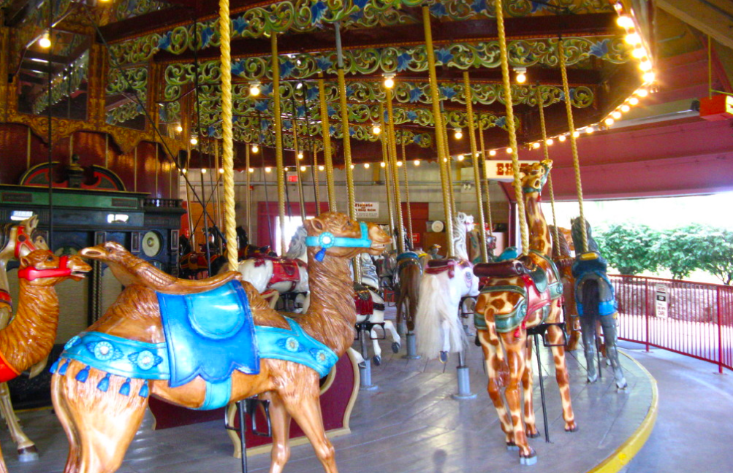

Lakeside Park Carousel

Description  
  
The Lakeside Carousel is a Charles I.D. Looff original, carved between 1898 and 1905 in Brooklyn, New York. The beautifully restored animals were carved by Looff's factory workers, including Marcus Charles Illions, who later went on to become a famed carousel-maker in his own right. Relocated in 1921, the carousel came to St. Catharines from its earlier home at an amusement park in Scarborough, now part of the City of Toronto. It was purchased for the amusement park flourishing in Port Dalhousie, which had 58 attractions. In those days, more than a quarter million people annually crossed the lake in steamships to visit Port Dalhousie on weekends. The carousel has 68 animals, including horses, lions, camels, goats and giraffes, plus four chariots.

After enjoying picnic lunch and maybe a ride on the carousel; approximately a 2- to 3-hour time frame, we are off to Niagara-on-the-Lake, to snoop around in the shops, have some ice cream, whatever you’d like.

We will have a chance to visit together for an evening meal. Many of us will use The Irish Harp Pub, located at 246 King Street, Niagara-on-the-Lake. There are no reservations for a separate room because of the peak season.

I have included a nice route back from the Niagara peninsula by back roads however some may want to get home by way of the QEW. (this is highlighted in green)

It should be a good day, Val and I, hope you can join us for memorable tour.