Ok we all agree that was a “3”

Trillium Miata Club

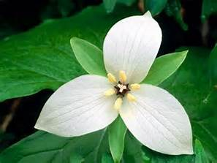



2018 OPEN GOLF TOURNAMENT

Building on the success of last year’s event, plans are complete for our 2018 3rd annual golf day. The tournament will again be held at the Doon Valley Golf Club in Kitchener Ontario, on the Classic Nine course. The club is easily accessible and provides all the amenities that we are looking for.

We will also retain the same winning format of a best ball program followed by a meal and awards presentation. However this year the meal & awards presentation will be held at a local restaurant facility only minutes drive from the course.

For 2018, we will be looking for a minimum of 20 golfers to a maximum of 40. Participants can enter either as individuals or as teams. Individuals will be assigned a team and teams will be balanced based on players stated skill levels. However, remember this is a fun tournament and your capability on the golf course is irrelevant.

So here are the details as of right now:

1. Date: Sunday August 19, 2018
2. Time: first tee off @ 1:00 pm. (players need to arrive by 12:30 pm to register at the pro shop and receive their cart assignment)
3. Where: Doon Valley Golf Club, Kitchener, Ontario
4. Cost: $37.50 per person covers 9 holes plus power cart and taxes
5. Restaurant: Crabby Joes, 440 Hespeler Road, Cambridge, N1R 6J7. 4:00 p.m. We will be ordering off the menu. https://www.crabbyjoes.com/main/

For additional information, please contact Rose Stipanitz. If you are coming from out of town and wish to stay over we can help you with that too!

If you prefer to register and pay by cash or cheque, please contact Rose Stipanitz.