Lake Placid Tour – Thursday or Friday for those Departing from Kingston

Route | Trillium 2022 Thursday & Friday
Distance | 276 km
Expected Travel Time | 3hrs, 28 minutes (plus border crossing)

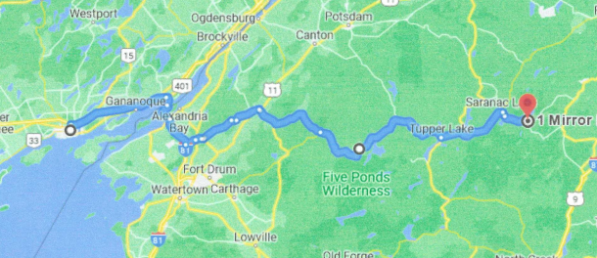

Departure – From Kingston Best Western Fireside Inn - 1217 Princess St Kingston, ON K7M 3E1

Take ON-401 E and I-81 S to Oxbow Rd in Theresa, United States (1 hour 3 min /85.3 km)
Turn Right onto Princess Street
Turn right onto McMichael Street
Turn Right onto Glengarry Rd
Turn left onto Sir John A Macdonald Blvd
Use the right lane to merge onto ON-401 via the ramp to Brockville/Cornwall
Take the exit onto ON-137S toward I-81/ Hill Islan / Ontario / 1000 Island Bridge
Toll Road – entering USA
Continue onto I-81 S
Keep left to stay on I-81 S
Take Exit 49 for NY-411 toward Theresa/Lafargeville
Turn left onto NY-411 E
Continue straight onto State Route 26 S
Turn left onto Commercial Street
Continue onto Milee Street

Follow County Rd 22 and County Rd 52 to W Main St in Gouverneur (24 min (29.5 km)
Turn left onto Oxbow Rd
Continue onto County Rd 22
Turn right onto County Rd 25
Continue onto County Rd 12/County Rd 52 (continue to follow County Rd 52)
Turn right onto W Main St

Follow NY-58 S to State Rte 3 E in Fine (25 min (35.9 km)
Turn left onto Hailesboro St
Turn right onto NY-58 S / William St (Continue to follow NY-58 S)

Continue on State Rte 3 E to Saranac Lake (1 hr 19 min (111 km)
Lunch Stop (McDonald’s in Tupper Lake)
Turn left onto State Route 3 E
Turn left onto Mll St
Turn left onto State Route 3 E / Park St

Take NY-86 E/Sara-Placid Rd to Mirror Lake Dr in Lake Placid (14 min (14.0 km)
Continue onto River St
Turn right onto Lake Flower Ave
Continue onto NY-86 E / Sara-Placid Rd
Turn left onto Mirror Lake Dr

1 Mirror Lake Dr – Destination – The Lake House - Lake Placid, NY 12946, USA
Route | Trillium 2022 Friday
Distance | 116 mi
Expected Travel Time | 2hrs, 48min
Notices | May include unpaved roads

Route: Lake Placid Tour 2022 – Friday - Early Bird Tour (For those arriving on Thursday)
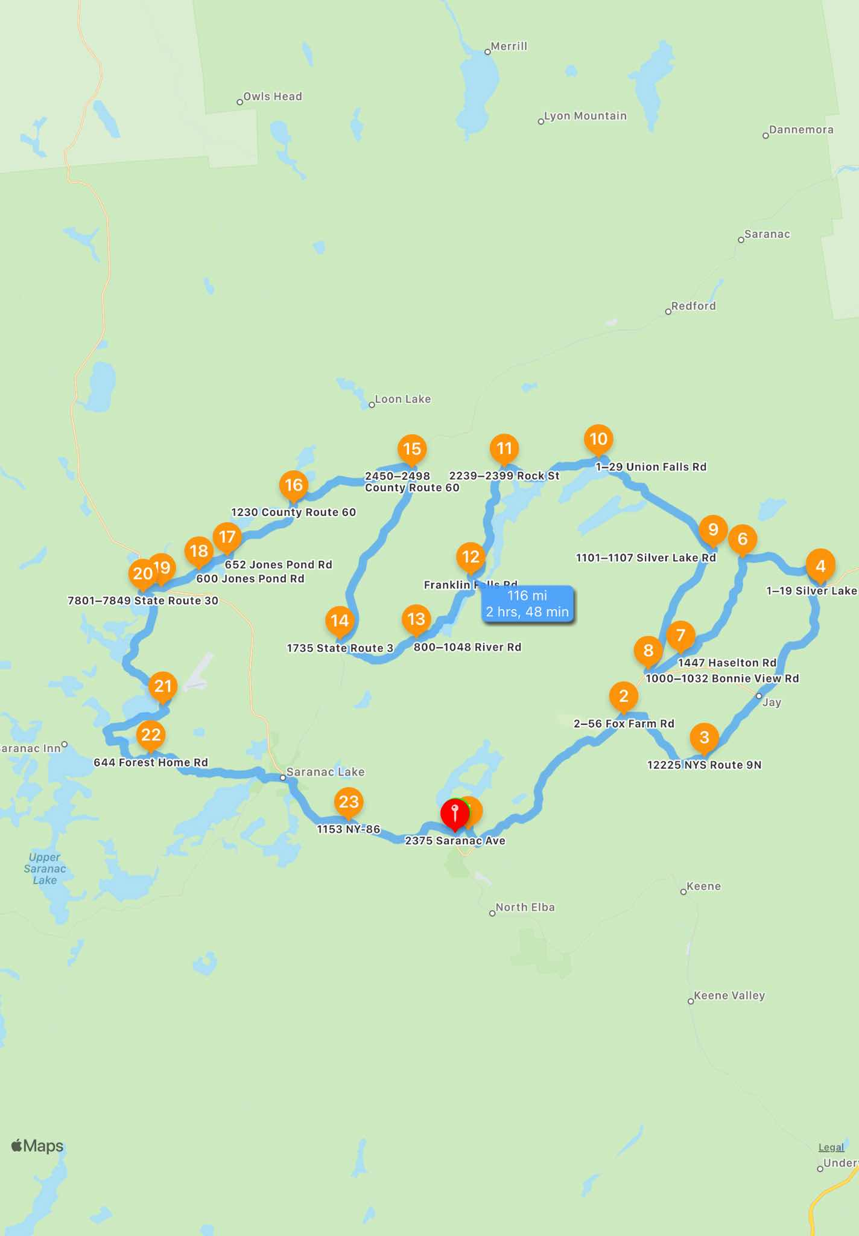
 | 246 Mirror Lake Dr Lake Placid NY 12946 United States (address is for same complex as 1 Mirror Lake Rd)  Depart: Thu, 4/21/22, 11:10 PM (EDT)  Next: 134 Northwood Rd; From here: 1 mi, 2min
0 ft | Proceed to the route
1 mi | Turn left onto Northwood Rd
85 ft | Arrive at the waypoint
 | 134 Northwood Rd Lake Placid NY 12946 United States  Arrive: Thu, 4/21/22, 11:12 PM (EDT)  From Start: 1 mi, 2min; Next: 2–56 Fox Farm Rd; From here: 9.7 mi, 12min
0.7 mi | Turn left onto Wilmington Rd
9 mi | Turn right onto Fox Farm Rd
163 ft | Arrive at the waypoint
 | 2–56 Fox Farm Rd Wilmington NY 12997 United States  Arrive: Thu, 4/21/22, 11:25 PM (EDT)  From Start: 11 mi, 15min; Next: 12225 NYS Route 9N; From here: 4.6 mi, 6min
0.8 mi | Turn right onto Springfield Rd
3.6 mi | Turn left onto NY-9N
729 ft | Arrive at the waypoint
 | 12225 NYS Route 9N Upper Jay NY 12987 United States  Arrive: Thu, 4/21/22, 11:32 PM (EDT)  From Start: 15 mi, 22min; Next: 5 N Main St; From here: 9.5 mi, 12min
9.3 mi | Turn left onto NY-9N
0.3 mi | Continue onto N Main St
140 ft | Arrive at the waypoint
 | 5 N Main St Au Sable Forks NY 12912 United States  Arrive: Thu, 4/21/22, 11:44 PM (EDT)  From Start: 25 mi, 34min; Next: 1–19 Silver Lake Rd; From here: 0.2 mi, <1min
737 ft | Turn left onto Silver Lake Rd
298 ft | Arrive at the waypoint
 | 1–19 Silver Lake Rd Au Sable Forks NY 12912 United States  Arrive: Thu, 4/21/22, 11:45 PM (EDT)  From Start: 25 mi, 35min; Next: 1–15 Haselton Rd; From here: 3.9 mi, 5min
0.8 mi | Keep left onto Silver Lake Rd
2.1 mi | Take a slight left turn onto Silver Lake Rd
1 mi | Take a slight left turn
281 ft | Arrive at the waypoint
 | 1–15 Haselton Rd Au Sable Forks NY 12912 United States  Arrive: Thu, 4/21/22, 11:51 PM (EDT)  From Start: 29 mi, 40min; Next: 1447 Haselton Rd; From here: 5.4 mi, 7min
213 ft | Turn left onto Haselton Rd
5.4 mi | Arrive at the waypoint
 | 1447 Haselton Rd Wilmington NY 12997 United States  Arrive: Thu, 4/21/22, 11:59 PM (EDT)  From Start: 34 mi, 48min; Next: 1000–1032 Bonnie View Rd; From here: 1.7 mi, 3min
1.3 mi | Turn right onto NY-86
0.4 mi | Turn right onto Bonnieview Rd
359 ft | Arrive at the waypoint
 | 1000–1032 Bonnie View Rd Wilmington NY 12997 United States  Arrive: Fri, 4/22/22, 12:02 AM (EDT)  From Start: 36 mi, 52min; Next: 1101–1107 Silver Lake Rd; From here: 5.9 mi, 7min
5.9 mi | Turn left onto Silver Lake Rd
116 ft | Arrive at the waypoint
 | 1101–1107 Silver Lake Rd Schuyler Falls NY 12912 United States  Arrive: Fri, 4/22/22, 12:10 AM (EDT)  From Start: 42 mi, 1hr; Next: 1–29 Union Falls Rd; From here: 6.5 mi, 7min
6.5 mi | Continue onto Union Falls Rd
156 ft | Arrive at the waypoint
 | 1–29 Union Falls Rd Saranac NY 12912 United States  Arrive: Fri, 4/22/22, 12:18 AM (EDT)  From Start: 49 mi, 1hr, 7min; Next: 2239–2399 Rock St; From here: 4.4 mi, 7min
4.3 mi | Turn left onto Rock St
135 ft | Arrive at the waypoint
 | 2239–2399 Rock St Au Sable Forks NY 12912 United States  Arrive: Fri, 4/22/22, 12:25 AM (EDT)  From Start: 53 mi, 1hr, 15min; Next: Franklin Falls Rd; From here: 5.3 mi, 10min
 | May include unpaved roads
5.3 mi | Turn left onto Franklin Falls Rd
128 ft | Arrive at the waypoint
 | Franklin Falls Rd Bloomingdale NY 12913 United States  Arrive: Fri, 4/22/22, 12:36 AM (EDT)  From Start: 58 mi, 1hr, 26min; Next: 800–1048 River Rd; From here: 4.2 mi, 7min
0.8 mi | Take a slight right turn onto River Rd
3.4 mi | Arrive at the waypoint
 | 800–1048 River Rd Bloomingdale NY 12913 United States  Arrive: Fri, 4/22/22, 12:43 AM (EDT)  From Start: 62 mi, 1hr, 33min; Next: 1735 State Route 3; From here: 3.9 mi, 5min
3.9 mi | Turn right onto NY-3
78 ft | Arrive at the waypoint
 | 1735 State Route 3 Bloomingdale NY 12989 United States  Arrive: Fri, 4/22/22, 12:49 AM (EDT)  From Start: 66 mi, 1hr, 39min; Next: 2450–2498 County Route 60; From here: 8.4 mi, 9min
8.3 mi | Turn left onto CR-60
175 ft | Arrive at the waypoint
 | 2450–2498 County Route 60 Vermontville NY 12989 United States  Arrive: Fri, 4/22/22, 12:58 AM (EDT)  From Start: 75 mi, 1hr, 48min; Next: 1230 County Route 60; From here: 5.8 mi, 7min
5.8 mi | Arrive at the waypoint
 | 1230 County Route 60 Vermontville NY 12989 United States  Arrive: Fri, 4/22/22, 1:06 AM (EDT)  From Start: 80 mi, 1hr, 56min; Next: 652 Jones Pond Rd; From here: 3.9 mi, 5min
3.8 mi | Turn right onto CR-31
399 ft | The waypoint is on your left
 | 652 Jones Pond Rd Rainbow Lake NY 12970 United States  Arrive: Fri, 4/22/22, 1:11 AM (EDT)  From Start: 84 mi, 2hrs, 1min; Next: 600 Jones Pond Rd; From here: 1.4 mi, 2min
1.4 mi | Arrive at the waypoint
 | 600 Jones Pond Rd Paul Smiths NY 12970 United States  Arrive: Fri, 4/22/22, 1:13 AM (EDT)  From Start: 86 mi, 2hrs, 3min; Next: 144–200 State Highway 86; From here: 1.8 mi, 2min
1.7 mi | Turn right onto NY-86
408 ft | Arrive at the waypoint
 | 144–200 State Highway 86 Paul Smiths NY 12970 United States  Arrive: Fri, 4/22/22, 1:15 AM (EDT)  From Start: 88 mi, 2hrs, 5min; Next: 7801–7849 State Route 30; From here: 1 mi, 1min
0.9 mi | Turn left onto NY-30
342 ft | Arrive at the waypoint
 | 7801–7849 State Route 30 Paul Smiths NY 12970 United States  Arrive: Fri, 4/22/22, 1:17 AM (EDT)  From Start: 88 mi, 2hrs, 7min; Next: 16 Junction Rd; From here: 6.5 mi, 7min
3.5 mi | Keep left onto NY-30
3 mi | Turn left onto Junction Rd
52 ft | Arrive at the waypoint. Then, turn around when possible.
 | 16 Junction Rd Saranac Lake NY 12983 United States  Arrive: Fri, 4/22/22, 1:24 AM (EDT)  From Start: 95 mi, 2hrs, 14min; Next: 644 Forest Home Rd; From here: 6 mi, 8min
52 ft | Turn left onto NY-30
0.2 mi | Turn right onto NY-30
2.7 mi | Turn left onto CR-18
3 mi | Arrive at the waypoint
 | 644 Forest Home Rd Lake Clear NY 12945 United States  Arrive: Fri, 4/22/22, 1:33 AM (EDT)  From Start: 101 mi, 2hrs, 23min; Next: 1153 NY-86; From here: 10 mi, 16min
5.1 mi | Turn right onto Ampersand Ave
646 ft | Turn left onto Edgewood Rd
0.3 mi | Turn left onto NY-3
0.8 mi | Continue onto River St
0.2 mi | Continue onto River St
0.3 mi | Turn right onto Lake Flower Ave
3.4 mi | Arrive at the waypoint
 | 1153 NY-86 Ray Brook NY 12977 United States  Arrive: Fri, 4/22/22, 1:49 AM (EDT)  From Start: 111 mi, 2hrs, 39min; Next: 2375 Saranac Ave; From here: 5.2 mi, 8min
0.4 mi | Keep left onto NY-86
3 mi | Keep left onto Saranac Ave
1.5 mi | Turn left onto Stevens Rd
0.3 mi | Turn right onto Mirror Lake Dr
384 ft | Turn right onto Saranac Ave
155 ft | Arrive at the destination
 | 2375 Saranac Ave Lake Placid NY 12946 United States  Arrive: Fri, 4/22/22, 1:58 AM (EDT)  Completed: 116 mi, 2hrs, 48min

Route | Trillium 2022 SATURDAY Morning
Distance | 146 mi
Expected Travel Time | 3hrs, 21min

Route: Lake Placid Tour 2022 - SATURDAY Morning
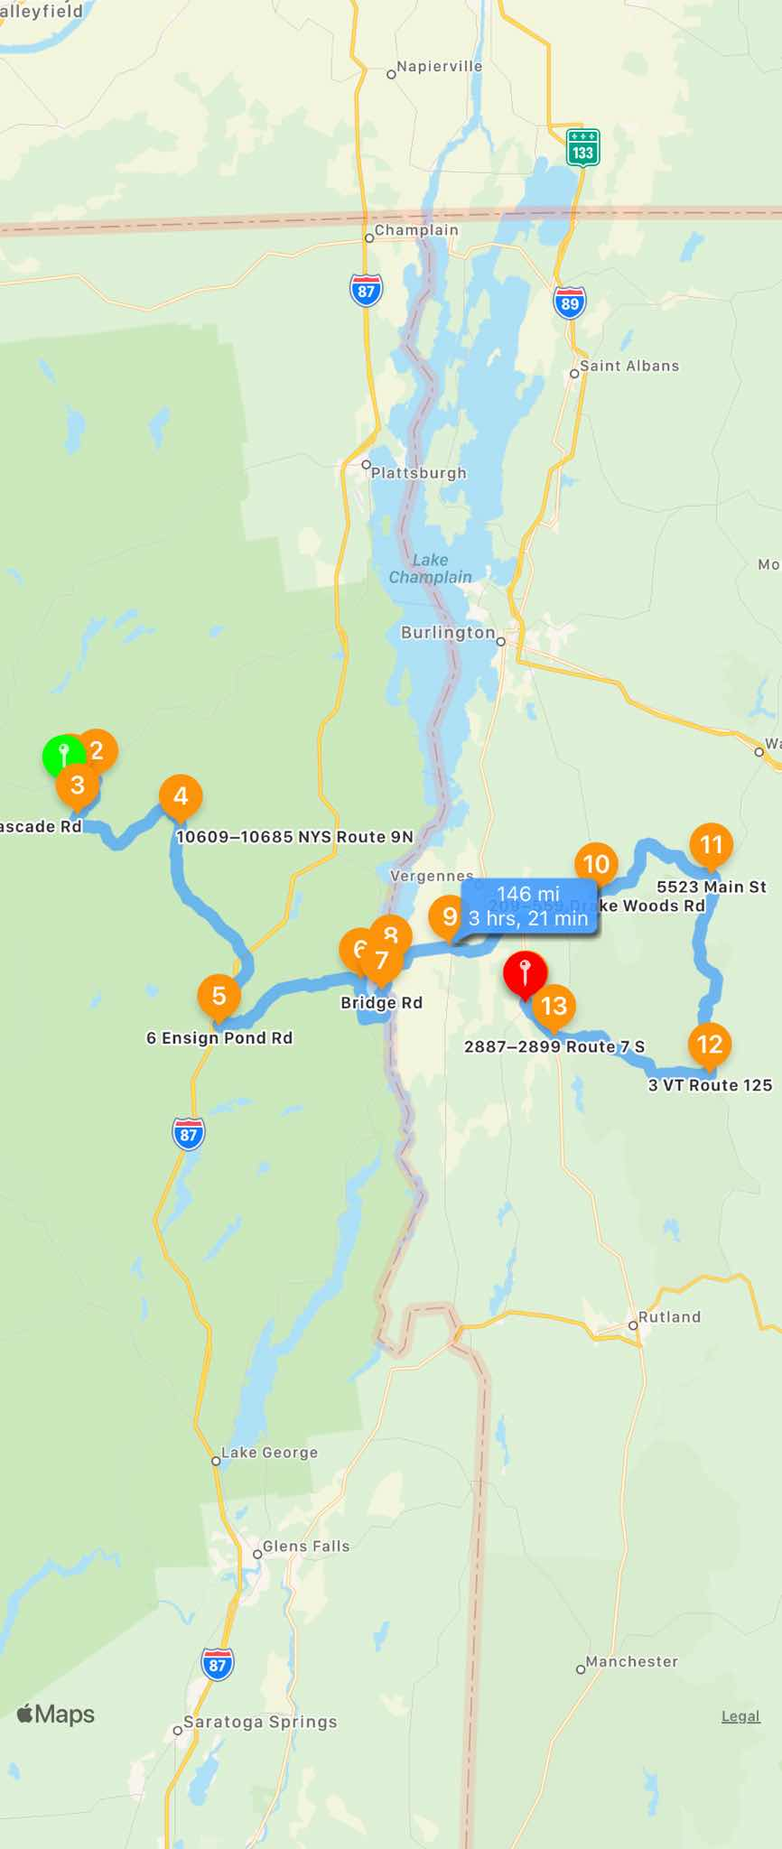
246 Mirror Lake Dr Lake Placid NY 12946 United States
Depart: Thu, 4/21/22, 11:10 PM (EDT)
Next: 134 Northwood Rd; From here: 1 mi, 2min
0 ft | Proceed to the route
1 mi | Turn left onto Northwood Rd
130 ft | Arrive at the waypoint
134 Northwood Rd North Elba NY 12946 United States
Arrive: Thu, 4/21/22, 11:12 PM (EDT)
From Start: 1 mi, 2min; Next: 728–898 River Rd; From here: 3 mi, 4min
0.7 mi | Turn left onto Wilmington Rd
2.3 mi | Turn right onto River Rd
178 ft | Arrive at the waypoint
728–898 River Rd North Elba NY 12946 United States
Arrive: Thu, 4/21/22, 11:17 PM (EDT)
From Start: 4 mi, 6min; Next: 5331–5399 Cascade Rd; From here: 4 mi, 7min
4 mi | Turn left onto Cascade Rd
216 ft | The waypoint is on your right
5331–5399 Cascade Rd North Elba NY 12946 United States
Arrive: Thu, 4/21/22, 11:24 PM (EDT)
From Start: 8 mi, 14min; Next: 10609–10685 NYS Route 9N; From here: 13 mi, 16min
13 mi | Arrive at the waypoint
10609–10685 NYS Route 9N Keene NY 12942 United States
Arrive: Thu, 4/21/22, 11:40 PM (EDT)
From Start: 21 mi, 30min; Next: 6 Ensign Pond Rd; From here: 21 mi, 25min
2.6 mi | Keep left onto NY-73
9.5 mi | Continue onto US-9 S
9 mi | Turn left onto Caza Turn Rd
847 ft | Turn left onto Ensign Pond Rd
322 ft | Arrive at the waypoint
6 Ensign Pond Rd North Hudson NY 12855 United States
Arrive: Fri, 4/22/22, 12:06 AM (EDT)
From Start: 43 mi, 55min; Next: 4299 Main St; From here: 15 mi, 23min
9.3 mi | Turn right onto Windy Hill Rd
4 mi | Continue onto Broad St
1.4 mi | Turn right onto Main St
503 ft | Arrive at the waypoint
4299 Main St Port Henry NY 12974 United States
Arrive: Fri, 4/22/22, 12:30 AM (EDT)
From Start: 57 mi, 1hr, 19min; Next: Bridge Rd; From here: 7.7 mi, 9min
3.6 mi | Turn left onto Bridge Rd
4.1 mi | Continue onto Vermont Rte 17 W
24 ft | Arrive at the waypoint
Bridge Rd Crown Point NY 12928 United States
Arrive: Fri, 4/22/22, 12:39 AM (EDT)
From Start: 65 mi, 1hr, 29min; Next: 5901–6015 VT Route 17 W; From here: 2.4 mi, 3min
2.4 mi | Arrive at the waypoint
5901–6015 VT Route 17 W Bridport VT 05491 United States
Arrive: Fri, 4/22/22, 12:43 AM (EDT)
From Start: 68 mi, 1hr, 32min; Next: 2700–2998 VT Route 17 E; From here: 6 mi, 7min
5.9 mi | Continue onto VT-17
152 ft | Arrive at the waypoint
2700–2998 VT Route 17 E Addison VT 05491 United States
Arrive: Fri, 4/22/22, 12:50 AM (EDT)
From Start: 74 mi, 1hr, 40min; Next: 209–559 Drake Woods Rd; From here: 16 mi, 22min
7.3 mi | Turn right onto Ethan Allen Hwy
633 ft | Turn left onto Main St
2.9 mi | Keep left onto Main St
5.8 mi | Turn right onto Drake Woods Rd
0.2 mi | The waypoint is on your left
209–559 Drake Woods Rd Bristol VT 05443 United States
Arrive: Fri, 4/22/22, 1:13 AM (EDT)
From Start: 90 mi, 2hrs, 3min; Next: 5523 Main St; From here: 16 mi, 23min
16 mi | Turn right onto Main St
500 ft | Arrive at the waypoint
5523 Main St Waitsfield VT 05673 United States
Arrive: Fri, 4/22/22, 1:37 AM (EDT)
From Start: 106 mi, 2hrs, 26min; Next: 3 VT Route 125; From here: 20 mi, 24min
20 mi | Turn right onto VT-125
133 ft | Arrive at the waypoint
3 VT Route 125 Hancock VT 05748 United States
Arrive: Fri, 4/22/22, 2:01 AM (EDT)
From Start: 125 mi, 2hrs, 51min; Next: 2887–2899 Route 7 S; From here: 16 mi, 22min
16 mi | Turn right onto Route 7 S
79 ft | Arrive at the waypoint
2887–2899 Route 7 S Middlebury VT 05753 United States
Arrive: Fri, 4/22/22, 2:24 AM (EDT)
From Start: 141 mi, 3hrs, 13min; Next: 24–98 Elm St; From here: 4 mi, 6min
3.7 mi | Turn left onto Court Square
114 ft | Turn right onto Court Square
0.3 mi | Turn left onto Elm St
57 ft | Arrive at the waypoint
24–98 Elm St Middlebury VT 05753 United States
Arrive: Fri, 4/22/22, 2:30 AM (EDT)
From Start: 146 mi, 3hrs, 20min; Next: 33 Seymour St; From here: 794 ft, <1min
619 ft | Turn left onto Seymour St
176 ft | Arrive at the waypoint
33 Seymour St Middlebury VT 05753 United States
Arrive: Fri, 4/22/22, 2:31 AM (EDT)
From Start: 146 mi, 3hrs, 20min; Next: 22 Seymour St; From here: 318 ft, <1min
317 ft | Arrive at the destination
22 Seymour St Middlebury VT 05753 United States
Arrive: Fri, 4/22/22, 2:31 AM (EDT); Completed: 146 mi, 3hrs, 21min

Route | Trillium 2022 SATURDAY afternoon
Distance | 78 mi
Expected Travel Time | 1hr, 48min
Route Type | Driving

Route: Trillium 2022 SATURDAY afternoon (REVISED)
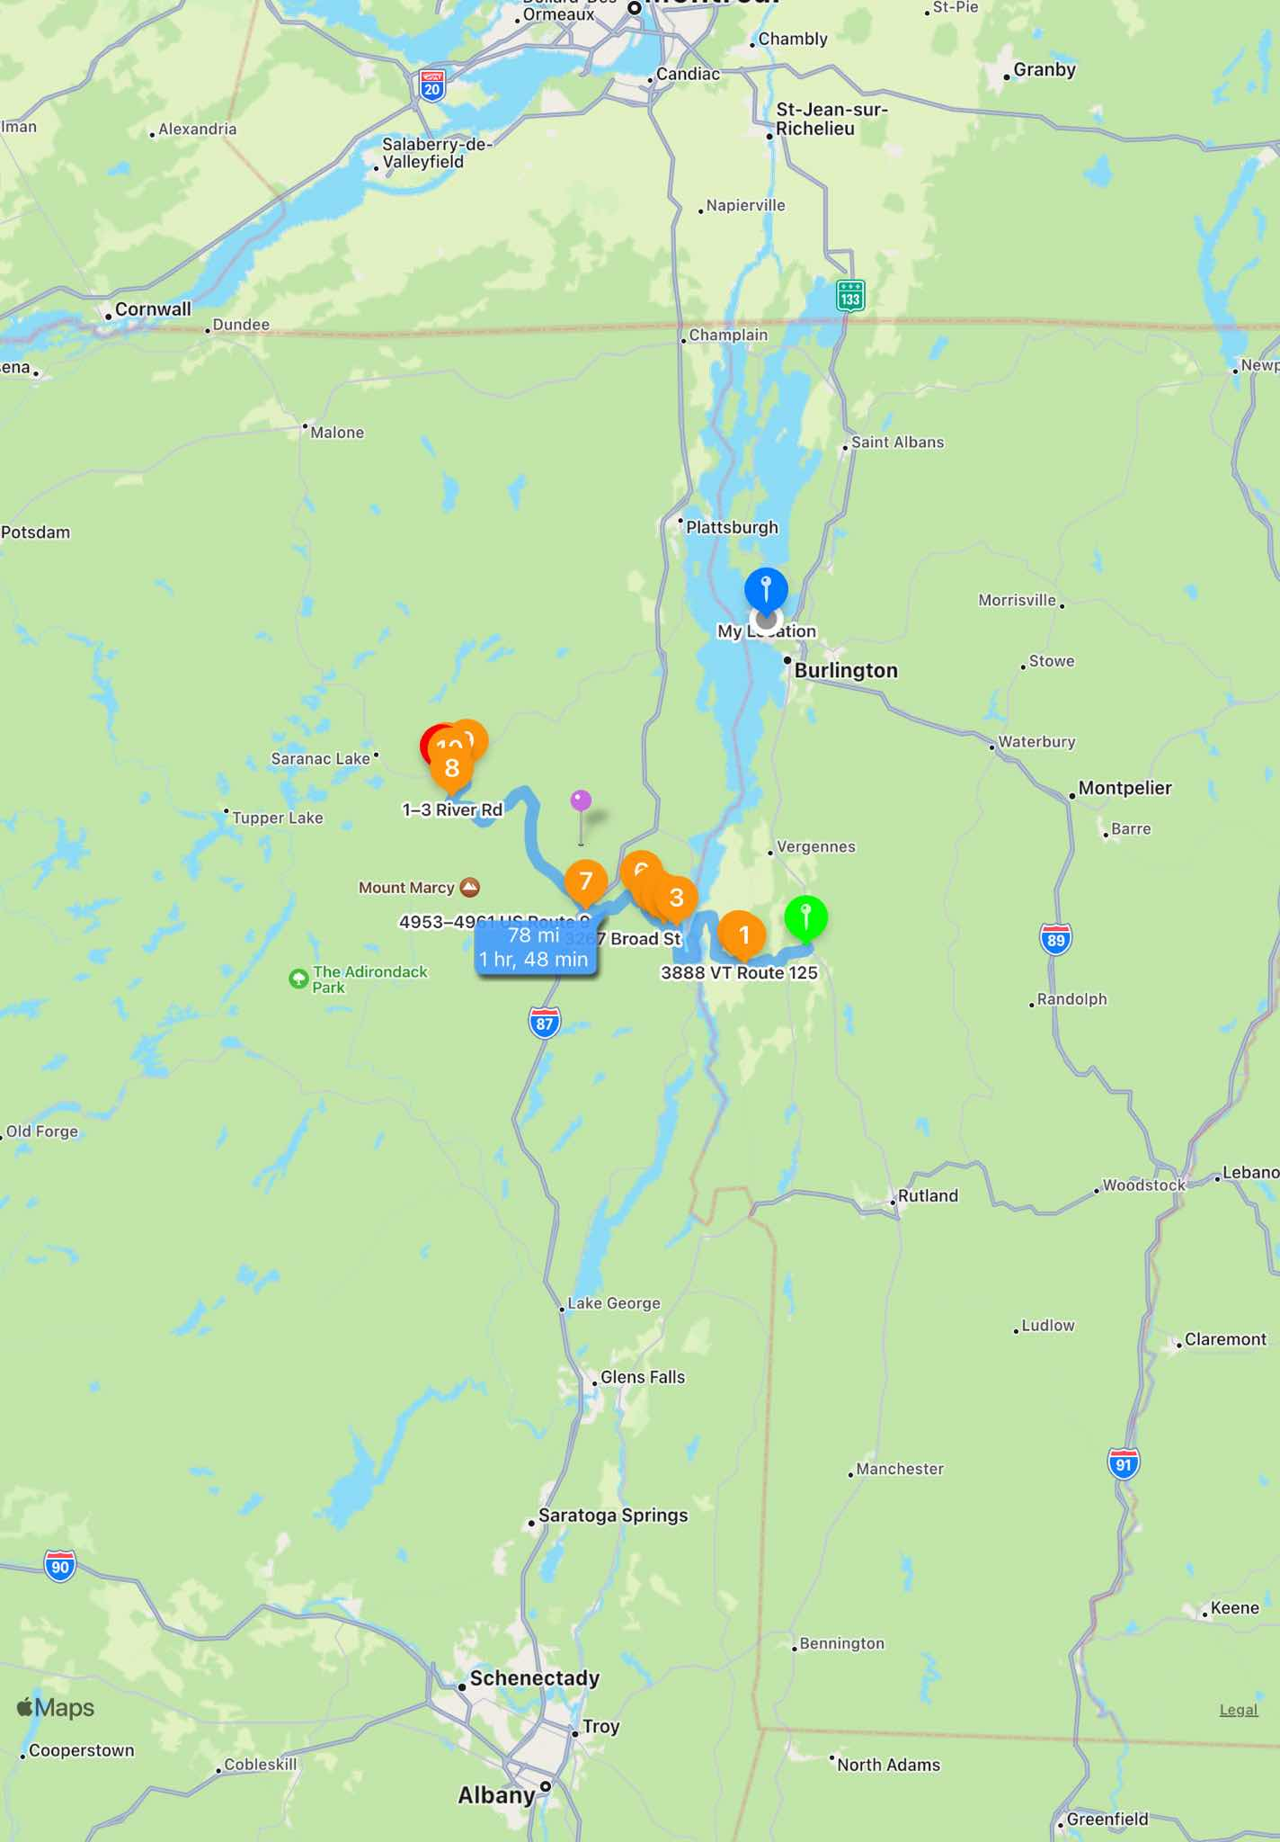
22 Seymour St Middlebury VT 05753 United States
Depart: Sun, 5/15/22, 6:51 PM (EDT)
Next: 2451–2493 VT Route 125; From here: 8.4 mi, 11min
0 ft | Proceed to the route
974 ft | Turn right onto Main St
0.2 mi | At the roundabout, take the first exit onto S Main St
72 ft | Take a slight right turn onto College St
8 mi | The waypoint is on your left
2451–2493 VT Route 125 Bridport VT 05734 United States
Arrive: Sun, 5/15/22, 7:03 PM (EDT)
From Start: 8.4 mi, 11min; Next: 3888 VT Route 125; From here: 1.1 mi, 1min
0.2 mi | Turn right onto VT-22A
0.4 mi | Turn left onto VT-125
0.4 mi | The waypoint is on your left
3888 VT Route 125 Bridport VT 05734 United States
Arrive: Sun, 5/15/22, 7:05 PM (EDT)
From Start: 9.5 mi, 13min; Next: 3267 Broad St; From here: 19 mi, 25min
3 mi | Turn right onto Basin Harbor Rd
4.5 mi | Turn left onto Church St
0.3 mi | Turn left onto Vermont Rte 17 W
0.9 mi | Keep left onto Vermont Rte 17 W
2.5 mi | Continue onto Bridge Rd
4.1 mi | Turn right onto NY-9N
3.7 mi | Turn left onto Broad St
94 ft | Arrive at the waypoint
3267 Broad St Port Henry NY 12974 United States
Arrive: Sun, 5/15/22, 7:30 PM (EDT)
From Start: 29 mi, 39min; Next: 2923 Dugway Rd; From here: 1.6 mi, 2min
1.3 mi | Turn right onto Dugway Rd
0.3 mi | Turn right
133 ft | Arrive at the waypoint. Then, turn around when possible.
2923 Dugway Rd Moriah NY 12974 United States
Arrive: Sun, 5/15/22, 7:33 PM (EDT)
From Start: 30 mi, 42min; Next: 19 Witherbee Rd; From here: 1.5 mi, 2min
133 ft | Turn right onto Dugway Rd
1.3 mi | Turn right onto Plank Rd
716 ft | Arrive at the waypoint
19 Witherbee Rd Moriah Center NY 12998 United States
Arrive: Sun, 5/15/22, 7:36 PM (EDT)
From Start: 32 mi, 44min; Next: 1642–1664 Tracy Rd; From here: 2.4 mi, 3min
2.2 mi | Keep right onto Witherbee Rd
865 ft | Turn left onto Tracy Rd
247 ft | Arrive at the waypoint
1642–1664 Tracy Rd Witherbee NY 12998 United States
Arrive: Sun, 5/15/22, 7:40 PM (EDT)
From Start: 34 mi, 48min; Next: 4953–4961 US Route 9; From here: 7.7 mi, 11min
7.7 mi | Turn right onto US-9
199 ft | Arrive at the waypoint
4953–4961 US Route 9 Moriah Center NY 12855 United States
Arrive: Sun, 5/15/22, 7:52 PM (EDT)
From Start: 42 mi, 1hr; Next: 1–3 River Rd; From here: 28 mi, 33min
2.3 mi | Take a slight left turn onto NY-73 W
13 mi | Continue onto NY-73
12 mi | Arrive at the waypoint
1–3 River Rd Lake Placid NY 12946 United States
Arrive: Sun, 5/15/22, 8:25 PM (EDT)
From Start: 70 mi, 1hr, 34min; Next: 3483–3499 Wilmington Rd; From here: 4.1 mi, 7min
70 ft | Turn right onto River Rd
0.5 mi | Keep left onto River Rd
3.5 mi | Turn left onto Wilmington Rd
268 ft | Arrive at the waypoint
3483–3499 Wilmington Rd Lake Placid NY 12946 United States
Arrive: Sun, 5/15/22, 8:32 PM (EDT)
From Start: 74 mi, 1hr, 41min; Next: 2–14 Northwood Rd; From here: 2.3 mi, 2min
2.3 mi | Turn right onto Northwood Rd
152 ft | Arrive at the waypoint
2–14 Northwood Rd Lake Placid NY 12946 United States
Arrive: Sun, 5/15/22, 8:35 PM (EDT)
From Start: 76 mi, 1hr, 44min; Next: 411–427 Mirror Lake Dr; From here: 0.7 mi, 1min
0.7 mi | Turn right onto Mirror Lake Dr
234 ft | Arrive at the waypoint
411–427 Mirror Lake Dr Lake Placid NY 12946 United States
Arrive: Sun, 5/15/22, 8:37 PM (EDT)
From Start: 77 mi, 1hr, 45min; Next: 1–11 Mirror Lake Dr; From here: 1 mi, 2min
1 mi | Arrive at the destination
1–11 Mirror Lake Dr Lake Placid NY 12946 United States
Arrive: Sun, 5/15/22, 8:39 PM (EDT)
Completed: 78 mi, 1hr, 48min

Route | Trillium 2022 SUNDAY
Distance | 166 mi
Expected Travel Time | 3hrs, 39min

Route: Lake Placid Tour 2022 - SUNDAY
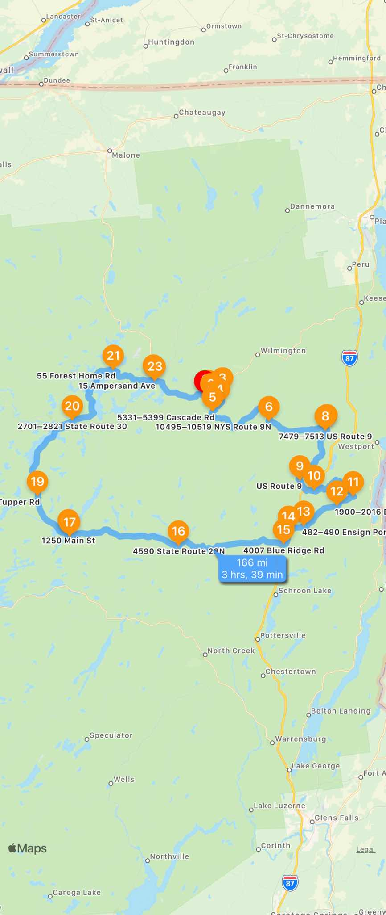
246 Mirror Lake Dr Lake Placid NY 12946 United States
Depart: Thu, 4/21/22, 11:12 PM (EDT)
Next: 134 Northwood Rd; From here: 1 mi, 2min
0 ft | Proceed to the route
1 mi | Turn left onto Northwood Rd
344 ft | Arrive at the waypoint
134 Northwood Rd Lake Placid NY 12946 United States
Arrive: Thu, 4/21/22, 11:15 PM (EDT)
From Start: 1 mi, 2min; Next: 88 Morningside Dr; From here: 0.7 mi, 1min
0.6 mi | Turn left onto Wilmington Rd
212 ft | Arrive at the waypoint
88 Morningside Dr Lake Placid NY 12946 United States
Arrive: Thu, 4/21/22, 11:16 PM (EDT)
From Start: 1.7 mi, 4min; Next: 728–898 River Rd; From here: 2.4 mi, 2min
2.3 mi | Turn right onto River Rd
430 ft | Arrive at the waypoint
728–898 River Rd Lake Placid NY 12946 United States
Arrive: Thu, 4/21/22, 11:19 PM (EDT)
From Start: 4.1 mi, 7min; Next: 346–406 River Rd; From here: 2.2 mi, 3min
2.2 mi | Arrive at the waypoint
346–406 River Rd Lake Placid NY 12946 United States
Arrive: Thu, 4/21/22, 11:23 PM (EDT)
From Start: 6.2 mi, 10min; Next: 5331–5399 Cascade Rd; From here: 1.8 mi, 3min
1.8 mi | Turn left onto Cascade Rd
292 ft | Arrive at the waypoint
5331–5399 Cascade Rd Lake Placid NY 12946 United States
Arrive: Thu, 4/21/22, 11:26 PM (EDT)
From Start: 8.1 mi, 14min; Next: 10495–10519 NYS Route 9N; From here: 14 mi, 17min
14 mi | Turn left onto NY-9N
362 ft | Arrive at the waypoint
10495–10519 NYS Route 9N Keene NY 12942 United States
Arrive: Thu, 4/21/22, 11:44 PM (EDT)
From Start: 22 mi, 31min; Next: 80 Park St; From here: 10 mi, 11min
9.7 mi | Turn left onto Park St
0.4 mi | The waypoint is on your right
80 Park St Elizabethtown NY 12932 United States
Arrive: Thu, 4/21/22, 11:55 PM (EDT)
From Start: 32 mi, 42min; Next: 7479–7513 US Route 9; From here: 0.4 mi, 1min
 | Bio-break location at Stewart’s Shops
496 ft | Turn right onto Court St
0.3 mi | Arrive at the waypoint
7479–7513 US Route 9 Elizabethtown NY 12932 United States
Arrive: Thu, 4/21/22, 11:56 PM (EDT)
From Start: 33 mi, 43min; Next: US Route 9; From here: 10 mi, 12min
9.8 mi | Keep left onto US-9 S
0.4 mi | Arrive at the waypoint
US Route 9 New Russia NY 12964 United States
Arrive: Fri, 4/22/22, 12:08 AM (EDT)
From Start: 43 mi, 56min; Next: 234–350 Tracy Rd; From here: 3.3 mi, 4min
1.9 mi | Turn left onto Tracy Rd
1.4 mi | The waypoint is on your right
234–350 Tracy Rd North Hudson NY 12855 United States
Arrive: Fri, 4/22/22, 12:13 AM (EDT)
From Start: 46 mi, 1hr; Next: 2630 Ensign Pond Rd; From here: 8.9 mi, 14min
6.4 mi | Turn right onto Witherbee Rd
0.3 mi | Continue onto Witherbee Rd
2.2 mi | Turn right onto Ensign Pond Rd
402 ft | Arrive at the waypoint
2630 Ensign Pond Rd Moriah Center NY 12961 United States
Arrive: Fri, 4/22/22, 12:27 AM (EDT)
From Start: 55 mi, 1hr, 15min; Next: 1900–2016 Ensign Pond Rd; From here: 3.3 mi, 5min
3.3 mi | The waypoint is on your left
1900–2016 Ensign Pond Rd Moriah Center NY 12961 United States
Arrive: Fri, 4/22/22, 12:32 AM (EDT)
From Start: 58 mi, 1hr, 20min; Next: 482–490 Ensign Pond Rd; From here: 6.9 mi, 10min
6.9 mi | The waypoint is on your left
482–490 Ensign Pond Rd North Hudson NY 12855 United States
Arrive: Fri, 4/22/22, 12:43 AM (EDT)
From Start: 65 mi, 1hr, 30min; Next: 3363 US Route 9; From here: 2.9 mi, 4min
2.3 mi | Turn left onto Caza Turn Rd
0.3 mi | Turn left onto US-9
0.3 mi | The waypoint is on your right
3363 US Route 9 North Hudson NY 12855 United States
Arrive: Fri, 4/22/22, 12:47 AM (EDT)
From Start: 68 mi, 1hr, 35min; Next: 4007 Blue Ridge Rd; From here: 2.5 mi, 3min
2.2 mi | Turn right onto Blue Ridge Rd
0.3 mi | The waypoint is on your right
4007 Blue Ridge Rd North Hudson NY 12855 United States
Arrive: Fri, 4/22/22, 12:51 AM (EDT)
From Start: 70 mi, 1hr, 38min; Next: 4590 State Route 28N; From here: 19 mi, 23min
 | Bio- break location at Sunoco Station
19 mi | Keep left onto Blue Ridge Rd
0.3 mi | Turn right onto NY-28N
316 ft | Arrive at the waypoint
4590 State Route 28N Newcomb NY 12852 United States
Arrive: Fri, 4/22/22, 1:14 AM (EDT)
From Start: 89 mi, 2hrs, 1min; Next: 1142 Main St; From here: 19 mi, 21min
19 mi | Turn right onto Main St
152 ft | Arrive at the waypoint
1142 Main St Long Lake NY 12847 United States
Arrive: Fri, 4/22/22, 1:36 AM (EDT)
From Start: 108 mi, 2hrs, 23min; Next: 1250 Main St; From here: 0.5 mi, 1min
0.5 mi | Arrive at the waypoint
1250 Main St Long Lake NY 12847 United States
Arrive: Fri, 4/22/22, 1:37 AM (EDT)
From Start: 109 mi, 2hrs, 24min; Next: 3027–3199 Tupper Rd; From here: 8.6 mi, 9min
8.6 mi | The waypoint is on your left
3027–3199 Tupper Rd Long Lake NY 12847 United States
Arrive: Fri, 4/22/22, 1:46 AM (EDT)
From Start: 117 mi, 2hrs, 34min; Next: 2701–2821 State Route 30; From here: 16 mi, 18min
12 mi | Turn right onto Stetson Rd
1.5 mi | Turn right onto NY-30
1.8 mi | The waypoint is on your left
2701–2821 State Route 30 Tupper Lake NY 12986 United States
Arrive: Fri, 4/22/22, 2:05 AM (EDT)
From Start: 133 mi, 2hrs, 53min; Next: 55 Forest Home Rd; From here: 14 mi, 17min
2.7 mi | Turn left onto NY-30
11 mi | Turn right onto CR-18
0.3 mi | Arrive at the waypoint
55 Forest Home Rd Lake Clear NY 12945 United States
Arrive: Fri, 4/22/22, 2:23 AM (EDT)
From Start: 148 mi, 3hrs, 10min; Next: 15 Ampersand Ave; From here: 7.9 mi, 11min
7.9 mi | Turn right onto Ampersand Ave
458 ft | Arrive at the waypoint
15 Ampersand Ave Saranac Lake NY 12983 United States
Arrive: Fri, 4/22/22, 2:34 AM (EDT)
From Start: 155 mi, 3hrs, 22min; Next: George Lapan Memorial Hwy; From here: 0.4 mi, 1min
189 ft | Turn left onto Edgewood Rd
0.3 mi | Turn left onto NY-3
499 ft | The waypoint is on your right
George Lapan Memorial Hwy Saranac Lake NY 12983 United States
Arrive: Fri, 4/22/22, 2:35 AM (EDT)
From Start: 156 mi, 3hrs, 23min; Next: 2375 Saranac Ave; From here: 9.8 mi, 15min
0.7 mi | Continue onto River St
0.2 mi | Continue onto River St
0.3 mi | Turn right onto Lake Flower Ave
3.7 mi | Keep left onto NY-86
3 mi | Keep left onto Saranac Ave
1.5 mi | Turn left onto Stevens Rd
0.3 mi | Turn right onto Mirror Lake Dr
384 ft | Turn right onto Saranac Ave
274 ft | Arrive at the destination
2375 Saranac Ave Lake Placid NY 12946 United States
Arrive: Fri, 4/22/22, 2:51 AM (EDT)
Completed: 166 mi, 3hrs, 39min

