**PAST PRESIDENT’S**

**INVITATIONAL TOUR**

**July 15/16, 2022**

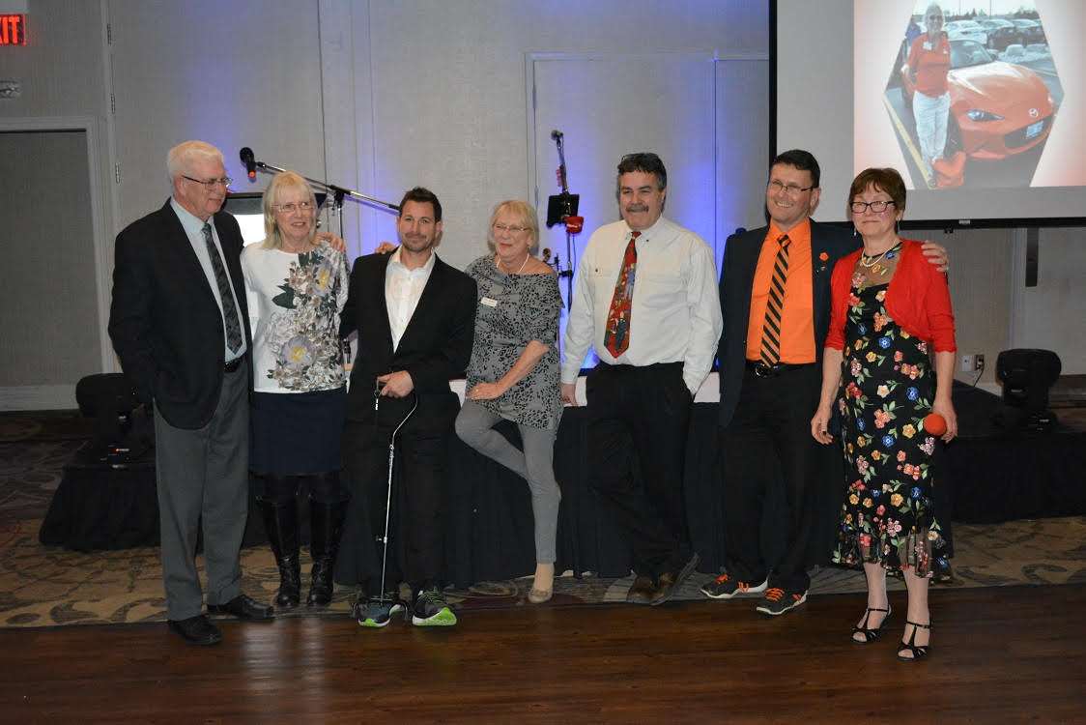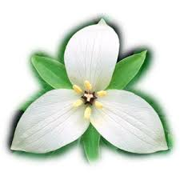

**Trillium Miata Club**